TeMA | Journal of  Land Use, Mobility and Environment

TeMA 1 (2015) 49-62
print ISSN 1970-9889, e- ISSN 1970-9870
DOI: xxxxxxxxxxxxxxxxxxxxx (by Editor)

review paper received xx Month 2015, accepted xx Month 2015 (by Editor)
Licensed under the Creative Commons Attribution – Non Commercial License 3.0
www.tema.unina.it

How to cite item in APA format:
Surname, N. (Year). Paper Title. Tema. Journal of Land Use, Mobility and Environment, Issue Volume (Issue Number), XXX-XXX. doi: http://dx.doi.org/10.6092/1970-9870/2431 (by Editor)

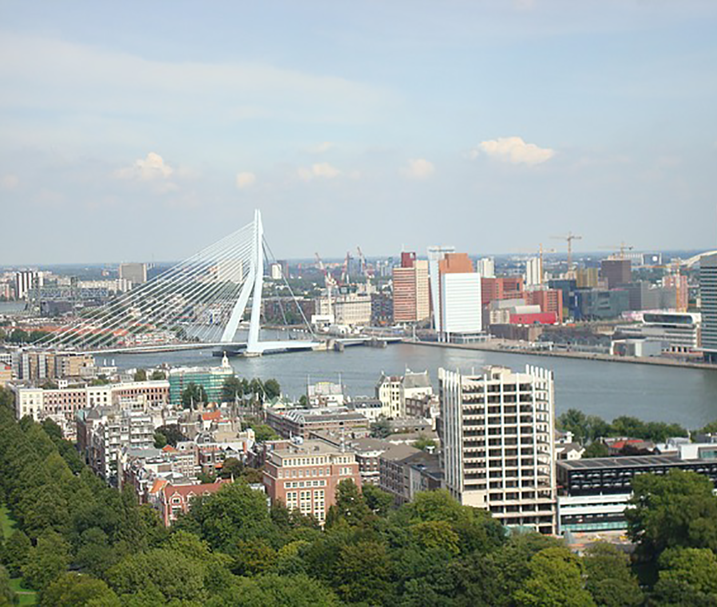  SMART AND RESILIENT CITIES  A SYSTEMIC APPROACH FOR DEVELOPING CROSS-SECTORAL STRATEGIES IN THE FACE OF CLIMATE CHANGE | ABSTRACT  Climate change is considered one of the main environmental issues challenging contemporary cities. Meanwhile, urban development patterns and the growth of urban population represent the main contributors to climate change, affecting the total energy consumptions and the related greenhouse gas emissions. Therefore, a breakthrough in current urban development patterns is required to counterbalance the climate-related issues.  This study focuses on the Smart City and Resilient City concepts that, according to current scientific literature, seem to play a leading role in enhancing cities’ capacities to cope with climate change.  In detail, based on the review of existing literature, this study analyzes the synergies between the two concepts, highlighting how the Smart City concept is more and more widely interpreted as a process addressed to make cities “more livable and resilient and, hence, able to respond quicker to new challenges” (Kunzmann, 2014). Nevertheless, current initiatives to improve cities’ smartness and resilience in the European cities are very fragmented and operational tools capable to support multi-objective strategies are still at an early stage.  To fill this gap, embracing a systemic perspective, the main characteristics of a smart and resilient urban system have been identified and framed into a conceptual model. The latter represents a preliminary step for the development of an operational tool capable to guide planners and decision-makers in carrying out multi-objective strategies addressed to enhance the response capacities of complex urban systems in the face of climate change.  KEYWORDS:  Smart City, Resilient City, Systemic Approach, Climate Change, Climate Adaptation
rocco PAPAª, adriana galderisi^{b}, Maria cristina vigo majello^{c}, erika saretta^{d}

^{a,b,c,d} Department of Civil, Architectural and Environmental
Engineering (DICEA) - University of Naples Federico II
e-mail: ªrpapa@unina.it, ^{b}galderis@unina.it, ^{c}vigo.majello@unina.it, ^{d}erika.saretta@unina.it
URL: URL: ª www.roccopapa.it, ^{b,c,d} www.dicea.dip.unina.it
According to the available trends and projections (UN, 2014), urban population has overcome the rural one since 2005 and it is expected to further increase by 2050. Even though cities represent only the 4% of the Earth’s land (UNEP, 2014), they consume about the 67% of the global primary energy (IPCC, 2014) and, due to urban lifestyle and economy, they are responsible for more than the 70% of greenhouse gas (GHG) emissions (Birkmann et al. 2010; EU, 2011) that are, in turn, the main contributors to climate change. Thus, according to current trends, the expected growth of urban population will further increase energy consumptions, worsening the current energy scenario. Moreover, the “continued emissions of greenhouse gases will cause further warming and changes in all components of the climate system” (IPCC, 2013), with effects that will be particularly severe in urban areas, due both to the concentration of people, assets and strategic activities and to the peculiarities of cities that may exacerbate the impacts of the heterogeneous climate-related phenomena.
Fortunately, cities can be interpreted as “cauldrons of diversity and differences and as fonts for creativity and innovation” (Florida, 2003): therefore, although playing a major role in the creation of current environmental challenges, they can be considered as a central part of any response.
Thus, mitigation strategies, addressed to reduce energy consumptions, combined with adaptation strategies, aimed at counterbalancing climate-related impacts, represent crucial challenges that cities have to deal with, in order to guarantee a sustainable urban environment for the rapidly growing urban population. Indeed, on the one hand, mitigation actions can allow the reduction of CO₂ emissions and, consequently, of climate-related impacts on urban areas. On the other hand, adaptation actions can enhance urban capacities to cope with unavoidable impacts of climate change (fig.1).
The issues related to the reduction of energy consumptions and to the urban adaptation to climate change have been considered as crucial in most of the recent metaphors related to urban development and addressed to improve cities capacities to cope with urgent environmental challenges (Moir et al., 2014): eco-cities, low-carbon cities, transition cities, smart cities, resilient cities represent only some examples.
We will focus here on the metaphors of “smart” and “resilient” cities, which seem to play a leading role due both to the growing attention paid by scholars all around the world to these terms and to the increasing number of on-going initiatives both on the global and on the European scale.
In detail, according to some scholars, 40 global cities will become smart by the year 2020 (EIP, 2014) and by 2025 the number of Smart City all around the globe will climb from 21 of the 2013 up to 88 (Smart City Council, 2014a).

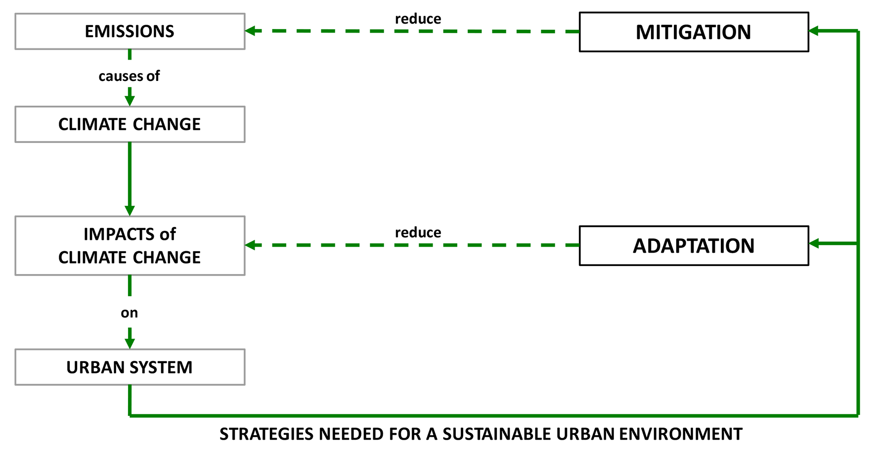 Fig. 1. Relations between urban system, climate changes, mitigation and adaptation (elaborated by Füssel et al., 2006).

Moreover, the European Commission has launched the European Innovation Partnership for Smart Cities and Communities for supporting “energy production, distribution and use; mobility and transport; and information and communication technologies (ICT)” to “improve services while reducing energy and resource consumption and greenhouse gas emissions” (EIP, 2013). Meanwhile, about 2100 cities all over the world have joined the “Making Cities Resilient” Initiative, launched in 2010 (UNISDR, 2012a) and, in December 2014, 100 cities have been selected by the Rockefeller Foundation Initiative for the “100 Resilient Cities Challenge” (Rockefeller Foundation, 2015). In Europe, a strategy addressed to enhance cities’ adaptation to climate change in order to realize a “more climate-resilient Europe” has been established (EU, 2013) and the “LIFE+ Program” focused on urban resilience (EU LIFE, 2014) has been launched.
Despite the numerous on-going initiatives, both Smart City and Resilient City are still vague and fuzzy concepts. In the case of the Smart City, about 30 definitions have been proposed since 2000 (Caragliu et al., 2009). In current literature a Smart City is generally characterized by the wide use of Information and Communication Technologies (ICTs) for traditional infrastructures as well as for improving the active participation of human and social capital (Caragliu et al., 2009; Toppeta, 2010; Dameri, 2013). Such technology-based approach is often considered capable of dealing with different urban problems (Batty et al., 2012; Lee et al., 2013), guaranteeing both the quality of the urban environment and the sustainability of its development. On the opposite, it is worth noting that not many definitions of Resilient City have been provided even though the concept of resilience – developed since the Seventies – seems to be particularly suitable for urban areas (Galderisi, 2014). Focusing on the resilience concept, some authors emphasize that resilience is “in danger of becoming a vacuous buzzword from overuse and ambiguity” (Rose, 2007), “increasingly viewed in a rather vague and malleable meaning” (Brand and Jax, 2007). Notwithstanding, some organizations agree on a definition of a Resilient City as a city capable to withstand or absorb the impact of hazards, shocks and stresses through adaptation or transformation, in order to guarantee a long-term sustainability, as well as its basic functions, characteristics and structures (UNISDR, 2012b; ICLEI, 2014a; Resilient City, 2014).
Thus, based on the review of existing literature and embracing a systemic perspective, this contribution will highlight synergies and mismatches between the two concepts, identifying the main characteristics of a smart and resilient urban system and framing them into a conceptual model, showing the relationships between these characteristics and outlining the processes for building up smart and resilient cities, according to different temporal perspectives, from short to long-term.
This study represents a first step for shifting from current “silo” approaches - based on the fragmentation of knowledge, strategies and responsibilities (EEA, 2014) - towards a systemic one. Such an approach could better support cross-sectoral strategies and multi-objective actions, more and more crucial in the face of climate change in an era of limited public resources, for enhancing the capacities of complex urban systems to deal with more and more interconnected challenges.

1 SMART AND RESILIENT CITIES: TOWARDS NEW PARADIGMS?
Currently, Smart City and Resilient City are drawing an increasing attention by urban planners, decision-makers and municipalities, as shown by the proliferation of academic researches, as well as of institutional initiatives on these topics. Thus, Smart City and Resilient City are becoming widespread labels, despite the lack of shared definitions.
Approaching the terms, the first issue arising refers to their definition as concept or paradigms: some scholars indeed refer to the Smart City as a paradigm (Auge et al. Blùm, 2012; New City Foundation, 2014; Bencardino and Greco, 2014), while others consider it as a concept (Washburn, 2011; Cretu, 2012; Dameri, 2013; BSI, 2013; EIP, 2013). It is worth noting that also halfway positions exist, looking at the Smart City as an emerging paradigm (Kunzmann, 2014). The Resilient City is a recent term based on resilience that some scholars define as a concept (Rose, 2007; Davoudi, 2012) or even as a “new umbrella concept”, able to take into account “risk management, ecological, sustainability or political sciences” (Chelleri, 2012), while others as a paradigm (Ercoskun, 2012; Rogers et al., 2012).
It has to be underlined that a paradigm can be defined as a “universally recognized scientific achievements that for a time provide model problems and solutions to a community of practitioners” (Kuhn, 1970); whereas a scientific concept is generally represented through three parts: a label, a theoretical definition that permits “others to understand our theory and be able to criticize and reproduce our observations” and an operational definition that “translates the verbal meaning provided by the theoretical definition into a prescription for measurement” (Suppe, 1997).
Hence, due both to the lack of a shared scientific definition of the two terms and to the heterogeneity of city programs and initiatives addressed to improve urban smartness and/or resilience, it seems hard to define them as paradigms: both Smart City and Resilient City contribute in offering solutions and opportunities for urban problems but, so far, they do not represent a “universally recognized scientific achievements”. On the opposite, they can easily considered as concepts: both of them are more and more used as urban labels (Hollands, 2008; Caragliu et al., 2009; Davoudi, 2012), numerous definitions of each term are currently available and, even though their operational definition is still at an early stage, some basic elements have been developed, such as domains (for the Smart City concept), characteristics and indicators.
Thus, according to such interpretation, definitions, evolution paths and goals of the two concepts will be reviewed and compared, highlighting their synergies and mismatches, as a starting point to develop an integrated operational approach to Smart City and Resilient City.
The Smart City concept has gained an increasing attention, in the last decade, by scholars, practitioners and decision-makers in conferences, scientific and political meetings, even though “a clear-cut, common definition of smart cities is still lacking” (Moser et al., 2014). The attention paid to this concept since the 2000 has significantly increased, not only in the scientific arena, as clearly highlighted by the search query data from Google Trends (fig.2), which provides information about how often, all over the world, a particular search-term is entered in respect to the total search-volume.
Studies and researches on Smart City developed in the last years, arising from different disciplinary fields and perspectives (academic, industrial, institutional) and focusing on different topics, have led to a number of heterogeneous definitions.

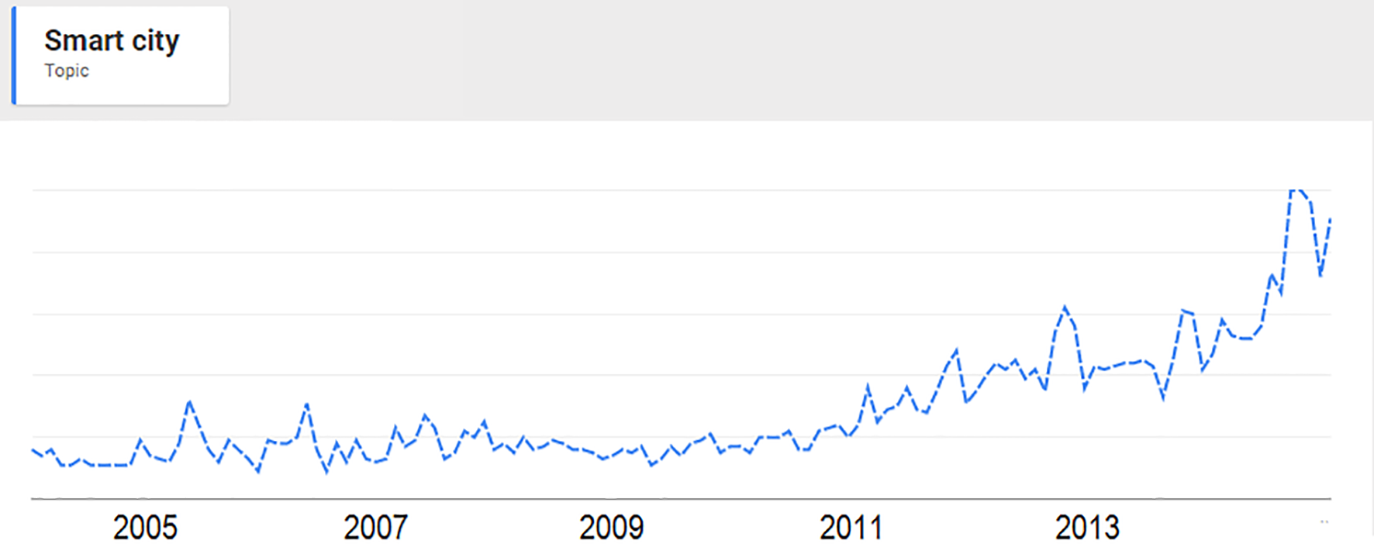
Fig. 2. Google Trends for "Smart City"

Some of them focuses on environmental issues, paying large attention to the efficient use of natural resources and to energy consumptions (EIP, 2013; Karnouskos et al., 2013, Kramers et al., 2014); others on socio-economic issues, highlighting the importance of social and human capital (Moser, 2001; Florida, 2003; Partridge, 2004; Glaeser and Berry, 2006; Giffinger et al., 2007; Dirks et al., 2010); others on institutional aspects, emphasizing the potential of ICTs in improving current decision-making processes and supporting the empowerment of local communities (Coe et al., 2001; Eger, 2009; Paskaleva, 2009).
Nevertheless, although the large variety of studies and researches focuses on different aspects, they agree on the crucial role of ICTs (Mosannenzadeh and Vettorato, 2014), assigning to technology different weights, according to the different disciplinary perspectives. Summing up, the numerous definitions of Smart City currently available bring out a variety of approaches and interpretations of the concept, although this multiplicity can be effectively reduced to two broad categories:
- a first one comprises the definitions referred to a “technology-based” approach, mainly focused on urban physical infrastructures (e.g., Hall, 2000; STERIA, 2011; Lazaroiu and Roscia, 2012; Aoun, 2013)
- a second one includes the definitions based on a holistic approach to the Smart City, capable to take into account the numerous and interconnected components that characterize an urban system (e.g., Giffinger et al., 2007; Nam and Pardo, 2011; Lee et al., 2013; Papa et al., 2013).
Among the numerous collected and analyzed definitions (approximately 30), the most relevant ones have been selected (Tab. 1), based on the number of quotations of the article comprising such definitions reported by Google Scholars. It is worth noting that all the selected definitions, which represent the most cited ones, refer to the second category. According to some scholars (Moir et al., 2014), also the “Resilient Cities is a concept growing in use”. The term appeared in 2002 in the “Resilient Communities Program Concept” and it was used by Pickett et al. (2004) as a “metaphor (…) to help link ecology and planning”.

Reference | Definition | Citations
Caragliu et al. 2009 | We believe a city to be smart when investments in human and social capital and traditional (transport) and modern (ICT) communication infrastructure fuel sustainable economic growth and a high quality of life, with a wise management of natural resources, through participatory governance. | 358
Komninos N. et al., 2011 | The Smart Cities concept (…) is connected to notions of global competiveness, sustainability, empowerment and quality of life, enabled by broadband networks and modern ICTs. | 291
Giffinger R. et al., 2007 | A Smart City is a city well performing in a forward-looking way in these six characteristics, built on the ‘smart’ combination of endowments and activities of self-decisive, independent and aware citizens. | 207
Nam T., Pardo T.A., 2009 | Smart city integrates technologies, systems, infrastructures, services, and capabilities into an organic network that is sufficiently complex for unexpected emergent properties to develop. | 103
Odendaal N., 2003 | A smart city or region (…) is one that capitalizes on the opportunities presented by Information and Communication Technology (ICT) in promoting its prosperity and influence. | 93
Batty M. et al., 2012 | A Smart City is a city in which ICT is merged with traditional infrastructures, coordinated and integrated using new digital technologies. Smart cities are also instruments for improving competitiveness in such a way that community and quality of life are enhanced. | 87
Tab.1. Smart City Definitions

The term was largely widespread thanks to the book edited by Vale and Campanella (2005) and titled “The Resilient City”. The volume focused on the persistence of cities in the face of disasters and namely on their capacity to “rebound from destruction”, being the cities “among humankind’s most durable artifacts”. Nevertheless, only recently the term “Resilient City” is gaining importance both in scientific debate and on the institutional level. Indeed, the Google Trends query for “Resilient City” (Fig. 3) highlights that the term entered the search queries in 2012, after the Sandy Hurricane that caused about 19 billion dollars of total damage. Such trend is arguably related to the priorities of national and local governments, which - in the face of the human and economic losses due to climate-related events - pushed towards the adoption of strategies and initiatives aiming at enhancing urban resilience, thereby promoting studies and research on this issue.
Also for the Resilient City concept, heterogeneous definitions are available; some of them have been provided by scholars (Newman et al., 2009; Fusco Girard et al., 2012), others by institutions (UNISDR, 2012a), large international organizations (World Bank Group, 2011) or private foundations (Rockefeller Foundation, 2015). Nevertheless, all the available definitions agree on the main idea that a resilient city is a city capable to absorb external pressures or to adapt or transform in front of such pressures, guaranteeing the safety of settled communities and the preservation of its basic functions during a crisis. Referring to the same temporal span, it is worth noting that the total number of definitions of the term Resilient City that can be found in current literature is by far lower than those available for Smart City. The most quoted definitions or the most widespread on the international level are shown in Table 2. Nevertheless, it has to be underlined that despite the definitions of Resilient City are fewer than those related to the Smart City, this concept roots in the wide research field focused on resilience, and namely on the resilience of social-ecological systems (Adger et al., 2005; Folke, 2006; Brand and Jax, 2007), to which a growing attention has been paid since the 2000 (Fig. 4). Numerous studies and researches have been carried in the last decades on the resilience of socio-ecological systems in the face of heterogeneous pressure factors, such as:
- natural hazards/climate change (e.g., Sapountzaki, 2010; Bahadur et al. , 2010; Jabareen, 2013; IPCC, 2013; Galderisi, 2014);
- energy consumptions and oil dependency (e.g., Newman et al., 2009; Hopkins, 2008; North, 2010);
- economy (e.g., Rose, 2007; Drobniak, 2010; Simmie and Martin, 2010).

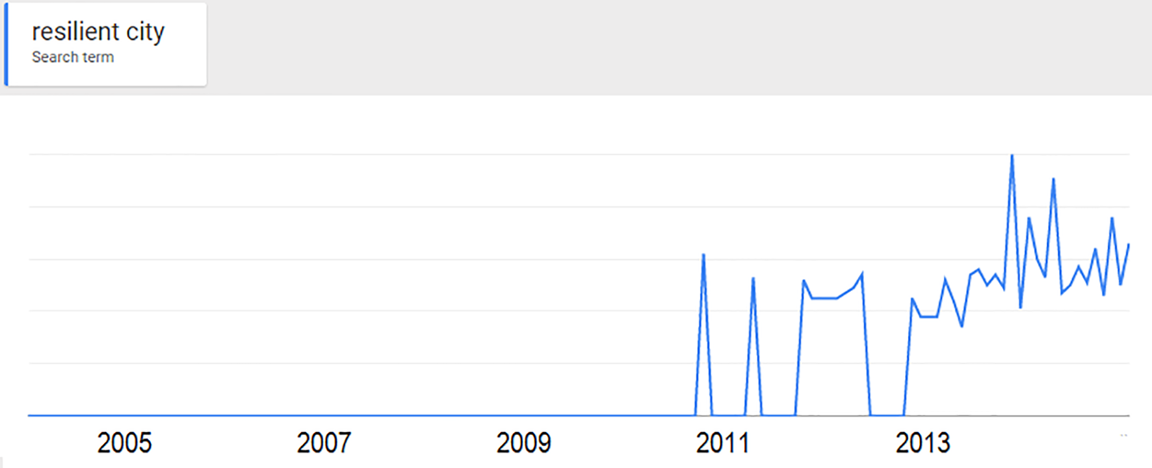
Fig. 3. Google Trends for "Resilient City”

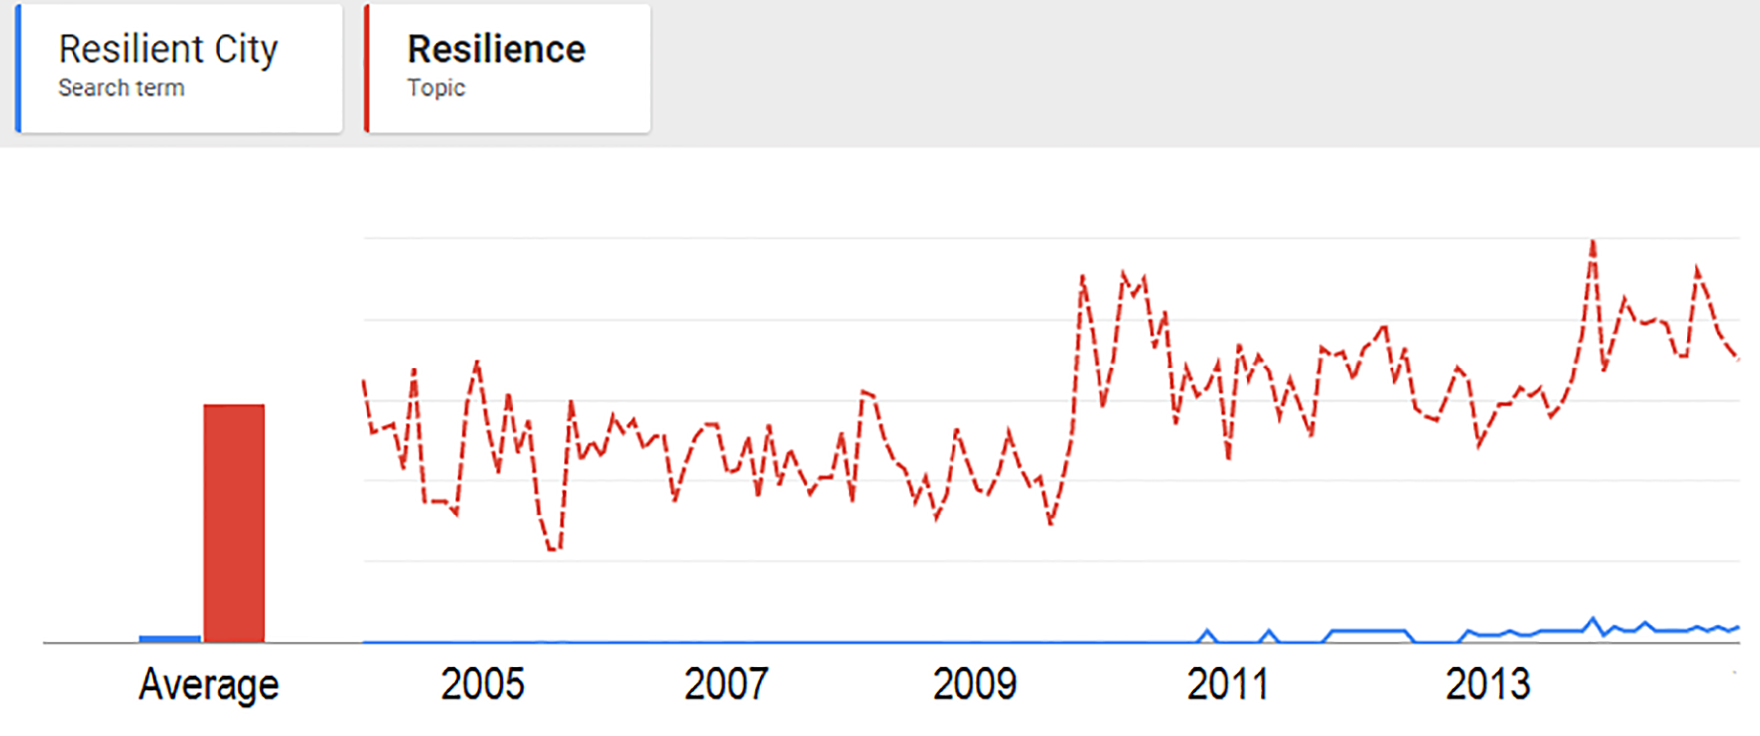
Fig. 4. Google Trends for "Resilience" (red) and for “Resilient City” (blue)

However, here we will refer only to the definitions of Resilient City, purposely neglecting the numerous and heterogeneous definitions of resilience, in order to allow a more immediate comparison with the Smart City definitions. Similarly to the case of Smart City, even in the most commonly used definitions of Resilient City there is a tendency to take into account different disciplinary perspectives, considering social, economic and environmental factors and their interrelationships as a key for an effective understanding of the complexity of urban systems and namely of their behaviors in the face of heterogeneous pressures. Briefly, according to the proposed definitions, the Smart City is a widespread label underlying a vision of the city based on the potential of ICTs as a key tool "to fuel sustainable economic growth and a high quality of life" (Caragliu et al., 2009).
The Resilient City promotes a vision of the city in which efforts are addressed to increase the ability of the city to respond to heterogeneous pressure factors (climate, environmental, energy and economic), with the ultimate aim of ensuring a higher quality of life and sustainable urban development. Furthermore, numerous scholars point out that ICTs, key tools for increasing urban smartness, could play a significant role also in reducing urban vulnerability and improving cities’ resilience.

Reference | Definition | Citations
Newman et al., 2009 | Resilient cities have built-in systems that can adapt to change, such a diversity of transport and land-use systems and multiple sources of renewable power that will allow a city to survive shortages in fuel supplies. | 344
Nijkamp P. et al., 2012 | A resilient city is also a creative city, able to reinvent a new equilibrium against destabilizing external pressure. It multiplies the potential of people to build new opportunities/alternatives. | 13
Resilient Communities Program Concept, 2002 | Resilient City is a city that supports the development of greater resilient in its institutions, infrastructure and social and economic life. Resilient cities reduce vulnerability to extreme events and respond creatively to economic, social and environmental change in order to increase their long- term sustainability. | n.a.
UNISDR, 2012 | A resilient city is characterized by its capacity to withstand or absorb the impact of a hazard through resistance or adaptation, which enable it to maintain certain basic functions and structures during a crisis, and bounce back or recover from an event. | n.a.
Tab.2. Resilient City Definitions

According to Heeks et al. (2013), indeed, “ICTs can help strengthen the physical preparedness of communities by helping those communities to optimize the location of physical defenses” and “can also strengthen institutions needed for the system to withstand the occurrence of climatic events”.
Summing up, the analysis and the comparison among the definitions of Smart City and Resilient City highlight important commonalities between the two concepts, even though the lack of clear-cut common definitions and the fact that both concepts are still evolving make a conclusion still open and harbinger of future research developments.

2. the evolution of the SMART AND RESILIENT CITY concepts
In the previous paragraph, the definitions of the Smart City and of the Resilient City have been compared with reference to a time span ranging from the 2000 to the 2014. However, the considered definitions already refer to an end-point, although not a final one, of an evolutionary process that is far more temporally extended since the roots of each concept, can be traced in research works carried out some decades ago. Hence, to better understand current similarities and/or differences among the two concepts of Smart and Resilient City, the evolution path of each concept will be sketched, highlighting the variety of contributions arising from different disciplinary fields that contributed to building up their current meanings.
In respect to the Smart City, it is worth reminding that the term "smart" has been primarily used in the Nineties by the Smart Growth American movement, which "refers to policies for the management of growth of urban and suburban settlement and to a set of principles for designing". Moreover, the Smart Growth also refers to “an idea of the city” capable to “provide an alternative to sprawl” (Pellegrini, 2003). The movement, mainly referred to the development of new residential areas, was addressed to reduce soil consumption and sealing, promoting more sustainable developments (Moccia, 2012).
Nevertheless, the main roots of the term Smart City as it is currently interpreted “have to be traced in some of the phenomena that characterized the Eighties and the Nineties, namely, in the evolution and diffusion of ICT and in their outcomes in terms of globalization of economy and markets” (ABB-Ambrosetti, 2012; Papa et al., 2013). The term Smart City was coined at the beginning of the Nineties in order to point out an urban development more and more dependent on technology and on innovation and globalization phenomena, mainly by an economic perspective (Gibson, Kozmetsky and Smilor, 1992).
Thus, since the Nineties ICT represented a key tool for increasing efficiency, attractiveness and competitiveness of cities. Starting from the early 2000s, large industries such as Cisco, Ericsson, IBM have significantly invested in the integration of ICTs within cities, strongly supporting the spread of a techno-centered approach to the Smart City concept. Nevertheless, in the mid of the 2000s a human-centered approach, focused on the key role of the human and social capital as starting levers for a “smart” urban development, began to take shape. In the second half of the 2000s, thanks to the study of Giffinger et al. (2007), the Smart City concept gained larger room in the scientific debate. Giffinger et al. (2007) provided a model of Smart City, interpreted as “a city well performing in 6 characteristics, built on the ‘smart’ combination of endowments and activities of self-decisive, independent and aware citizens” and a method for measuring and comparing urban smartness. The six characteristics - or, better, the sectors in which a Smart City has to ensure high performances - can be identified as follows: smart economy; smart people; smart governance; smart mobility; smart environment; smart living.
Hence, this study paved the way to an integrated approach to the Smart City concept and, based on this numerous scholars have recently provided an interpretation of the smart city as a city in which ICTs are addressed to improve the overall urban performances and, above all, the quality of life of citizens. Among them, the research work carried out by Caragliu et al., (2009), focused on the relationships among technological and social aspects, intellectual capital, health and governance issues, and the studies of Mark Deakin (2012), who proposed the model of the "Triple Helix" for promoting social innovation, stressing on the close relationships between sustainable development and Smart City.
As a result, recently “a broader conceptualization of Smart Cities places emphasis on good city governance, empowered city leaders, smart or ‘intelligent citizens’ and investors in tandem with the right technology platform” (Moir et al., 2014), supporting strategies addressed to improve both “hard” (infrastructures, ICTs, etc.) and “soft” urban components (human and social capital).
As mentioned above, the term "Resilient City" gained large attention by institutions, policy makers and scholars after the Hurricane Sandy that, in 2012, hit the North Eastern part of the USA and the city of New York, causing 43 deaths and economic damage for about 19 billion dollars. In the last years, the constantly increasing popularity of the concept is mainly due to its widespread use and promotion by international organizations (eg. the UNISDR that in 2010 launched the Making Cities Resilient campaign, addressed to involve local Authorities and enhance urban resilience in the face of natural and man-made hazards); private organizations (eg. the Rockefeller Foundation, which identifies specific "challenges" that cities have to deal with - from natural hazards to social issues – promoting the initiative "100 Resilient Cities") and associations of cities and local governments (eg, ICLEI that deals with urban resilience against climate-related impacts).
Although the concept of Resilient City has recently come to the fore, the studies on resilience have been developed since the Fifties through different disciplinary fields, from physics to psychology, from ecology to management science. Referring to previous research works for an exhaustive description of the evolution path of the resilience concept (Martin-Breen and Anderies, 2011; Alexander, 2013; Galderisi, 2014), we will here point out some milestones along this path. Resilience found large room in Ecology during the Seventies, thanks to Holling (1973) that firstly focused on the behavior of natural systems in the face of external perturbations. In the mid of the Nineties, Holling provided a clear distinction between an engineering and an ecological approach to resilience. According to Holling (1996), engineering resilience refers to stability, efficiency, constancy, predictability, return time to a previous state and, above all, to the idea of a single, stable equilibrium, using “resistance to disturbance and speed of return to equilibrium (…) to measure the property”. On the opposite, ecological resilience emphasizes “conditions far from any equilibrium steady state”, recognizes the existence of multiple equilibrium states and can be measured according to ”the magnitude of disturbance that can be absorbed before a system changes its structure”. Thus, ecological resilience focuses on the twofold possibility for a system to absorb changes, maintaining its main features, below a given threshold of disturbance, or change its state, moving towards a different one, not necessarily better than the previous one, above such a threshold.
The engineering perspective has been largely widespread in the studies on risks, as opportunity for improving cities’ capacities to deal with emergency and recover from disasters (e.g., IFRC, 2011; Vale and Campanella, 2005; Gunderson, 2010): according to this perspective, resilience has been interpreted as the capacity of a system to return to a previous equilibrium steady-state, to “bounce back” after disturbances.
The “ecological” approach to resilience has been significantly strengthened when the focus of studies and researches on resilience shifted from natural to socio-ecological systems and intertwined with those related to the complex adaptive systems, capable of learning from experience, processing the information, adapting and even transforming themselves in face to changes. By this perspective, resilience was less and less conceived as a bounce-back to a previous state and progressively adapted to the behavior of complex systems, that is non-linear, self-organizing, characterized by uncertainty and discontinuities (Berkes et al., 1998; Holling, 2001; Walker et al., 2004; Bankoff et al., 2004).
Recent research works have further extended the concept of resilience, defining the latter as a “dynamic interplay of persistence, adaptability and transformability across multiple scales” (Folke et al. 2010). Moreover, some scholars have pointed out the importance of “continual learning” (Cutter et al., 2008), providing an idea of resilience as ‘bouncing forward’, which includes the idea of ‘improvement’ of systems’ essential structures and functions (IPCC, 2012).
Hence, current approaches to resilience seem more appropriate to grasp the complexity of urban systems’ evolution (Davoudi, 2012; Chelleri et al., 2012) and suitable for framing urban policies in the face of a large set of heterogeneous phenomena, from the climate-related impacts to the scarcity of resources. In some cases, indeed, the concept of persistence, addressed to improve the capacity of a system to withstand sudden impacts and to rapidly and effectively recover previous conditions, can be significant. In other cases, being current conditions unsustainable or inadequate, novelty and innovation become crucial to drive the system’s transition towards new conditions. The milestones of the evolution path of the resilience concept are shown in fig. 6; it has to be noticed that the Resilient City definitions mainly refer to the more recent interpretation of Resilience, since it is generally interpreted as a city capable to absorb, adapt and/or change in the face of external pressures. However, although the Resilient City concept is nowadays largely widespread among planners and decision makers, some scholars highlight the numerous criticalities that may arise when the resilience concept is applied to urban systems. For example, human intervention is not taken into account in the "adaptive cycle" of ecological systems, while it is crucial in case of urban systems; moreover, the need for clarifying the goals - “resilience to what ends?” – as well as the field of action - “resilience of what to what?” – and the beneficiaries - “resilience for whom?” – of policies addressed to enhance urban resilience have been largely emphasized (Davoudi, 2012).
These criticalities point out the need for improving urban resilience taking into account both “hard” and “soft” components of urban systems. The former refer to structural, technical, mechanical, and cyber systems’ qualities, capabilities, and functions of infrastructures. The latter are “related to family, community, and society, focusing on human needs, behaviors, psychology, relationships, and endeavors” (Kahan et al., 2009). The difference between "hard" and "soft" components is also highlighted by some of the major networks devoted to the resilience issues (e.g., ICLEI, 2014; ACCCRN, 2012) and it is largely mirrored in the field of adaptation strategies and measures that are generally distinguished between “hard”, when they “involve capital-intensive, large, complex, inflexible technology and infrastructure”, and “soft”, when they “prioritize natural capital, community control, simplicity and appropriateness” (Hallegatte, 2009; Sovacool, 2011).
Summing up, even though the term Smart City is rooted in the evolution and spread of ICTs and in their outcomes in terms of globalization of economy and markets, along its evolution path it has been increasingly used to indicate a city in which ICTs are addressed to improve the overall urban performances and, above all, the quality of life of citizens. The concept of resilience – which underlies the Resilient city concept – extending the concept of resilience from natural to socio-ecological and urban systems and embracing change and complexity, is more and more interpreted as a key concept for improving cities’ performances in the face of the different factors currently threatening their future development, by managing a large set of interconnected properties and adaptive capacities (Norris et al., 2008; Galderisi and Ferrara, 2012).
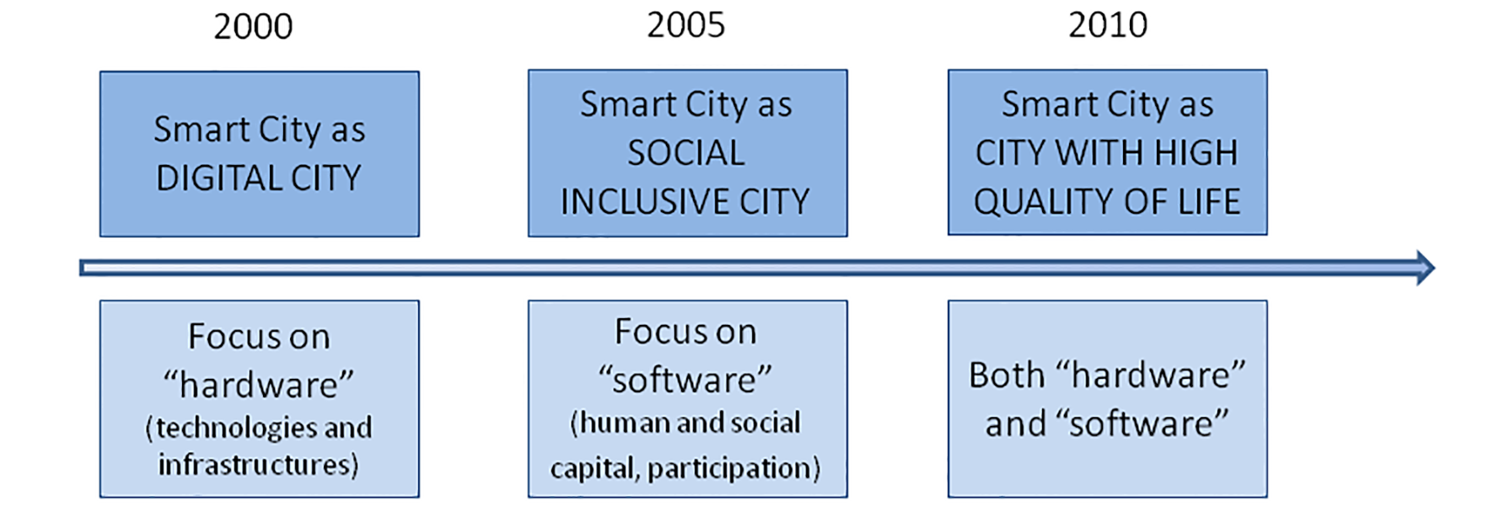
Fig. 5. Evolution of the Smart City concept

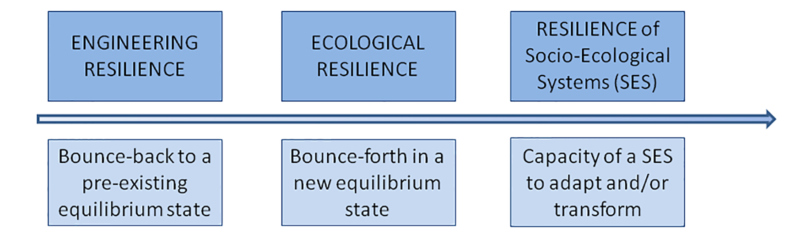
Fig. 6. Evolution of the Resilient City concept

Thus, both the concepts are currently interpreted as key concepts for improving urban performances, even though the Smart City concept puts large emphasis on the role of ICTs, while the Resilient City concept focuses on the inherent capabilities of cities to deal with the heterogeneous factors (from hazards to climate change, from environmental degradation to poverty) threatening cities’ development. Moreover, both of them aim at providing strategies and measures acting on “hard” (infrastructures, technological systems, etc.) and “soft” components (capacities and behaviors of communities and institutions) of urban systems.

3. the aims of the SMART AND RESILIENT CITY concepts
Based on the analysis of the definitions and of the evolution paths of the Smart and Resilient City concepts some commonalities between the two concepts can be outlined, even though, as clearly highlighted in the previous paragraph, each concept has its own peculiarities. To further investigate the relationships between the two concepts, the main goals of each concept have been deepened.
According to the vast scientific literature on these issues, both the Smart City and Resilient City are mainly addressed to improve sustainability and increase the quality of life, although each concept seem to pursue these objectives following different paths.
As regards sustainability, in the Smart City this goal is primarily pursued through a wide use of ICTs that, allowing a more efficient and effective management of networks (energy, transport, etc.), may led to a significant reduction in energy consumptions. In a broader sense, “a smart sustainable city is an innovative city that uses information and communication technologies (ICTs) and other means to improve quality of life, efficiency of urban operation and services, and competitiveness, while ensuring that it meets the needs of present and future generations with respect to economic, social and environmental aspects” (ITU, 2014).
Nevertheless, it is worth noting that the large use of ICTs may also negatively affect sustainability, at least in respect to:
- environmental aspects, in that the production of ICTs involves an intensive use of raw materials that are assembled in not recyclable devices (Wagener, 2008) and, above all, the use of ICTs induces high-energy consumption (Viitanen and Kingston, 2014). As remarked by Wagener (2007), indeed, “large cities with a high concentration of knowledge workers, office buildings, and ICT are likely to find that ICT energy use is significantly higher than national averages” (Wagener, 2007). Nevertheless, “green IT is a new emerging field of study that brings together both environmental sustainability and information technology (IT) and explores the ways in which they connect with each other” (Lombardi, 2011);
- socio-economic aspects, in that the use of “ICTs would increase the risk to human health, including stress and conflict due to inequality” (Viitanen and Kingston, 2014) among individuals and/or institutions that have access to ICT and that, above all, are able to use them properly.
Thus, according to current literature, social and environmental sustainability represent a “major strategic component of smart cities” (Caragliu et al., 2009), even though relevant aspects, such as the issues related to the potential of green ICTs or to the social inclusion, should be further investigated.
According to Folke (2002), resilience and sustainability are tightly connected concepts, due to the need for creating and maintaining prosperous social, economic and ecological systems also in the face of uncertain events. Some scholars emphasize that resilience represents a “necessary approach to meet the challenge of sustainable development” (Chelleri et al., 2012) or a way of thinking for planning sustainable cities, capable to meet "the needs of the present without compromising the ability of future generations to meet their own needs” (Brundtland Report, 1987).
Nevertheless, similarly to what has been highlighted for the smart city, some scholars point out some inconsistencies between resilience and sustainability (TURAS, 2012; Redman, 2014): in detail, while resilience puts large emphasis on uncertainty and discontinuities and is largely interpreted as the result of the dynamic interplay of persistence, adaptability and transformability (Davoudi, 2012), sustainability is often interpreted in a “fail-safe” approach as a concept aimed at “achieving stability, practicing effective management and the control of change and growth” (Ahern, 2011)
The increase of the quality of life is the other main goal of both Smart and Resilient City. In the Smart City, the widespread use of ICTs allows, for example, “to improve mobility on many levels, increasing spatial and a-spatial accessibilities to jobs, leisure, social opportunities and so on, thereby enabling the citizenry to increase their levels of life satisfaction” (Batty et al., 2012). Moreover, ICTs allow the reduction of energy consumptions and CO₂ emissions by allowing citizens to get a better air quality and a better environment.
The empowerment of citizens thanks to the use of ICT (Navarrete, 2012) represents a largely emphasized feature of the Smart City. It refers to a process of "social engagement" that creates a widespread sense of social cohesion, a significant awareness of the issues relevant to the community and allows people to propose and activate common objectives and actions (Zani, 2012). Thus, citizens’ empowerment is a way to support decision-making processes based on a broad-base views of citizens and, therefore, to ensure development processes more participatory, collaborative and, in one, capable to effectively respond to the need of local communities.
Nevertheless, according to some scholars, “the paradox is that the same networked technologies that offer opportunities for empowerment can be used against civil rights for surveillance and censorship, or at worst, direct oppression” (Viitanen and Kingston, 2014).
Moreover, even though numerous scholars underline that the Smart City is addressed to increase “livability” (Toppeta, 2010; Chourabi et al., 2012; Smart City Council, 2014a), most of available definitions put “emphasis on business-led urban development” (Caragliu et al., 2009).
For example, the main aim of the study on European Smart Cities carried out by Giffinger et al. (2007) is to analyze the medium-sized European cities in order to find out their strengths and improve their competitiveness. The Smart City concept is, indeed, “principally open to any societal goals linked to it, but due to its focus on innovation systems, priority is given implicitly to competitiveness and economic growth” (Wolfram, 2012).
Also the Resilient City concept is addressed to increase the quality of life. A resilient city is, indeed, capable to absorb, adapt and/or change in the face of the main environmental challenges threatening its future, in order to preserve natural and man-made resources and, above all, to guarantee citizens’ safety. It is worth reminding that, according to the five-stage model of human needs outlined by Maslow in 1943, safety is one of the basic needs that people have to fulfill, immediately after the biological and physiological ones. Therefore, to ensure the safety of people is a key objective for guaranteeing high levels of quality of life.
As it clearly arises from the above, the two investigated concepts, Smart City and Resilient City, show numerous commonalities, despite some differences. As regards the former, it has to be noticed that both of them result from a long and multidisciplinary evolution path capable to take into account the multiple and interrelated aspects of a complex urban systems, are addressed to pursue goals related to sustainability and quality of life and can be implemented through “hard” and “soft” measures.
Among the main differences, it is worth noting that while the spread of the Smart City concept has been strongly supported by large industries, the Resilient City concept has been mainly promoted by international organizations as well as by associations of cities and local governments.
Moreover, whereas the common ground among the definitions of Smart City can be found in the use of ICTs as a tool for empowering cities and citizens in the face of heterogeneous challenges, but above all as a key tool to fuel economic growth and competitiveness, the common ground of the definitions of Resilient City can be traced in the enforcement of the fundamental capacities of an urban system to deal with external pressures (from climate change to environmental degradation). Nevertheless, according to the more recent interpretations of the Smart City concepts, ICTs should be better addressed to solve long-term environmental challenges and to improve cities’ resilience rather than primarily focus on consumer electronics. According to Heeks et al. (2013), indeed, “ICTs can help strengthen the physical preparedness of communities by helping those communities to optimize the location of physical defenses” and “can also strengthen institutions needed for the system to withstand the occurrence of climatic events”.
Hence, the Smart City concept seems more and more to underlie a process, a multi-objective strategy of integrated urban and ICT development, capable to tackle problems of economic competitiveness but also of social equity and environmental performance (Wolfram, 2012). Such a process should allow cities to “become more livable and resilient and, hence, able to respond quicker to new challenges” (Kunzmann, 2014). Therefore, a better integration between the two often separated concepts and following strategies seem to be widely desirable and already pursued by some. Nevertheless, such integration has to be based on a robust scientific approach capable to provide methodological and operational tools for promoting cross-sectoral and multi-objective strategies capable to improve urban smartness and resilience, by providing citizens with a better urban environment capable to favor cohesion, sense of community and, meanwhile, safety and prosperity. Moreover, it is worth emphasizing that a multi-objective strategy addressed to build up a smarter and a more resilient city should be carefully tailored on the peculiarities of local contexts, in that each city has to define its own objectives and priorities, through a shared and participatory process (BSI, 2014).

4 BUILDING UP SMART AND RESILIENT CITIES: A conceptual model
According to the preliminary findings presented in the previous paragraph, it seems possible to state that, on the one hand, the Smart City concept is widely interpreted as a process capable to tackle urban problems related to economic competitiveness but more and more focused on issues related to social equity and environmental performances (Wolfram, 2012). On the other hand, the Resilient City is largely interpreted as a process addressed to empower cities and citizens to cope with external - environmental, social, economic - pressures. Hence, due to the relevant synergies between the two concepts, some authors emphasize the increasing area of overlapping among them, highlighting that resilience is more and more frequently included among the Smart Cities’ objectives and that smart initiatives are often addressed to allow cities to “become more livable and resilient and, hence, able to respond quicker to new challenges” (Kunzmann, 2014). Moreover, some international organizations and networks as well as numerous cities are promoting integrated strategies for building up smarter and more resilient cities, as a key step for effectively counterbalance the challenge of climate change as well as for pursuing a better integration between mitigation and adaptation strategies (Klein et al., 2005).
For example, the American Planning Association (APA) has “created a Smart Cities and Sustainability Task Force, whose mission is to address advances in technology and innovation to cultivate cities which are smarter, more resilient and sustainable” (McMahon, 2014); the Asian Cities Climate Change Resilience Network (ACCCRN), funded by the Rockefeller Foundation, is striving for “developing smarter, resilient cities in India” (ACCCRN, 2015).
Nevertheless, as mentioned above, an effective theoretical framework – which is crucial for developing operational tools capable to support integrated and multi-objective strategies – is still missing. To fill this gap, the study focuses on the characteristics of Smart and Resilient cities and provides some hints for guiding a process aiming at improving cities’ smartness and resilience in the face of climate change. In detail, based on the available scientific literature, first of all the characteristics common to both the Smart and the Resilient city concepts have been selected; then, grounding on previous studies focused on the Resilient City (Bahadur et al., 2010; Martin-Breem and Marty Anderies, 2011; Galderisi, 2013) and on the Smart City (Sinkiene et al., 2014; BSI, 2014) the most important ones for each concept have been identified. In the following (tab. 3 and 4) all the selected characteristics have been listed and briefly explained.

Resilient City Concept | Characteristic | Smart City Concept
The “capacity to maintain a system in its current stability domain” (Berkes et al., 2002) | Adaptability | The capacity to adapt to unforeseen situations (Ratti & Townsend, 2011)
“It’s the ability to constantly assess, take in new information, reassess and adjust your understanding of the most critical and relevant strengths and weaknesses and other factors” (Rockefeller F., 2014) | Awareness | It is related to the capacity of knowing and understand the urban potentialities (Giffinger et al., 2007)
It refers to the existence of multiple opportunities and incentives for a broad participation of stakeholders, as in public-private partnerships (Godschalk, 2003). | Collaboration | It is related to coordination and is defined as a step of the city technology harmonization, characterized by synergies and interactions between elements, resource and actors (BSI, 2014)
It represents the achievement of higher level of functioning by adapting to new circumstances and learning from the disaster experience (Maguire & Hagan, 2007) | Creativity | It is related to the creative capital that co-determines, fosters and reinforces trends of skilled migration (Florida, 2003; Caragliu and Nijkamp, 2008)
Diversity of species performing critical functions, diversity of knowledge, institutions and human opportunity and diversity of economic supports all have the potential to contribute to sustainability and adaptive opportunity (Berkes et al., 2002) | Diversity | It can be referred to the social and ethnic plurality (Giffinger et al., 2007) or to the diversity of specific elements, e.g. transportation modes (Caragliu et al., 2009).
“Fundamental property for service system and entails that performance are realized with modest resource consumption” (Fiksel, 2003) | Efficiency | It is related to the capacity of systems and infrastructures to optimize their performances (Aoun, 2013; Kramers et al., 2014).
It is a key aspect of adaptive capacity when unexpected events occur (Godshalk, 2003) and it is the capacity of a system to cope with an impact without being permanently altered (Tasan-Kok, 2013) | Flexibility | It is the ability to change, specifically referred to labor market and human capital (Giffinger et al., 2007)

Resilient City Concept | Characteristic | Smart City Concept
“Innovation is seen as novel ways of doing things, or how new things can be made useful, and refers to incremental or radical changes in ideas, practices, and products; including novel ways of organizing society, changing its rules and institutions” (Ernstson et al., 2010) | Innovation | Changes made to something established, or a new introduction as new methods, ideas, or products, to achieve desirable outcomes that result in small but significant improvement (BSI, 2014)
Dynamic systems require to constantly revise existing knowledge to enable the management of the system and the adaptation to change (Stockholm Resilient Centre, 2014) | Learning | The human ability to gain knowledge or skill through ICT (Coe et al., 2001) or as the collection of data and their elaboration (Wolfram, 2012)
The ability to create networks of non-identical elements, or actors, called “nodes” that are connected by diverse interactions or links (Chuvarayan et al., 2006) | Networking | The capacity to connect computers and devices through communications channels that facilitate communications among users, allowing them to share resources and services (BSI, 2014)
The capacity to “build trust and relationships needed to improve legitimacy of knowledge and authority during decision making processes”, as well as “create a shared understanding and uncover perspectives that may not be acquired through more traditional scientific processes” (Rockefeller F., 2014) | Participation | The capacity to involve civil society organizations, stakeholders, communities and citizens in policy-making and public debate (BSI, 2014)
Table 3. Common characteristics of Resilient City and Smart City

It is worth underlining that most of the literature related to the resilience of socio-ecological systems focuses on the concept of self-organization, by interpreting this concept as a key feature of a resilient system (Walker et al., 2004; Chuvarajan et al., 2006; Folke et al., 2006). However, according to numerous scholars, self-organization has been here intended as an inherent characteristic of complex systems, such as the urban systems. It “can be defined”, indeed, “as the spontaneous emergence of global structure out of local interactions. Spontaneous means that no internal or external agent is in control of the process (…). This makes the resulting organization intrinsically robust and resistant to damage and perturbations” (Heylighen, 2008). According to such interpretation, self-organization has not been included among the selected characteristics. Nevertheless, self-organizing mechanisms that will arise as a consequence of the internal and external changes of the systems should be adequately understood and monitored.
Then, to better understand how these characteristics act and interact for improving the response capacities of complex urban systems in the face of climate change, a further step is required. Climate change is indeed a challenging threat that requires long term as well as short-medium term strategies. Thus, on the one hand, long-term strategies capable to reduce GHG emissions and energy consumptions, by promoting cities’ transition from current energy consuming development patterns towards low-carbon patterns, are required; on the other hand, short-medium term adaptation strategies, aimed at reducing the vulnerability of urban systems to the heterogeneous impacts of climate-related phenomena, ranging from sudden (e.g. flash floods, heat waves, etc.) to slow (e.g. droughts) phenomena and to improve cities capacities to better cope with more and more “beyond the expected” or even “unexpected” phenomena, have to be developed.

Characteristic | Concept | Definition
Connectivity | Resilient City | It is related to “the density of the links within the network, i.e., the number of links divided by the maximum possible number of links” and to the “reachability, or the extent to which all the nodes in the network are accessible to each other” (Janssen et al., 2006)
Knowledge | Resilient City | The capacity to elaborate knowledge and learn from management mistakes, protecting a system from the failure due to subsequent management actions based on incomplete knowledge and understanding (Berkes, 2004)
Memory | Resilient City | “The ability of a system to preserve knowledge and information” (Folke et al., 2005)
Modularity | Resilient City | “It is the degree to which a system's components may be separated and recombined” (Elmqvist, 2013)
Persistence | Resilient City | System's ability to withstand an impact, preserving its own characteristics and structure, except for a temporary departure from the ordinary functioning conditions (Folke et al., 2010)
Redundancy | Resilient City | Spare or superfluous “elements, systems, or other units (..) capable of satisfying functional requirements in the event of disruption, degradation, or loss of functionality” (Bruneau et al., 2003; Walker and Salt, 2006; Schultz et al., 2012; Tyler & Moench, 2012).
Resistance | Resilient City | The degree to which systems are displaced (or disturbed) by a given physical force or pressure (Carpenter et al., 2001)
Resourcefulness | Resilient City | “The capacity to (…) mobilize resources when conditions exist that threaten to disrupt some element, system, or other unit of analysis" including "the ability to apply material and human resources to meet established priorities and achieve goals" (Bruneau et al., 2003)
Robustness | Resilient City | The "ability of elements, systems, and other units of analysis to withstand a given level of stress or demand without suffering degradation or loss of function" (Bruneau et al., 2003).
Transformability | Resilient City | “Capacity of people to create a fundamentally new social-ecological system when ecological, political, social or economic conditions make the existing system untenable” (Walker et al., 2004)
Anticipation | Smart City | Capacity to conceive future predictable scenarios. Indeed, a smart city can provide “tools to exploit various sources of information about human behavior to aid in the allocation of resources—land, water, transportation, and so on—as the city evolves” (Naphade et al., 2011)
Monitoring | Smart City | “The capacity to monitor all critical infrastructures is crucial for a smart city in order to better optimize its resources, plan its preventive maintenance activities, and monitor security aspects while maximizing services to its citizens” (Hall, 2000)
Reliability | Smart City | Degree to which a measure repeatedly and consistently produces the same result (BSI, 2014)
Table 4. The most important characteristics of Smart City and Resilient City

It is worth stressing that, in respect to the different time spans (short-medium-long term) that characterize the response of a complex urban system in the face of climate change, the selected characteristics play different roles. Therefore, in order to highlight their roles and linkages in the different phases, the selected characteristics have been framed into a conceptual model (Fig. 7).
So far numerous and heterogeneous models on Smart and Resilient City have been developed; these models can be distinguished at least into three different categories:
- "theoretical" models that, based on scientific theories, are addressed to understand and represent cities’ dynamics and development;
- "operational" models, which provide a vision for urban development and outline a path for achieving it;
- "hybrid" models, combining a solid theoretical background with some operational elements.
The Smart City literature is largely focused on “operational” models, defining intervention sectors for projects implementation (Lekamge and Marasinghe, 2013), despite the lack of a "solid theoretical framework for smart cities" (Harrison et al., 2011).
In the Resilient City literature, some “theoretical” models, addressed to investigate the main characteristics of a resilient city (Tyler and Moench, 2012; Davoudi, 2013; Galderisi, 2013), as well as some “operational” models aimed at supporting municipalities in developing strategies for disaster risk reduction (Mehrotra et al., 2009; Prasad et al., 2010) or for climate adaptation (e.g., Climate-Adapt Platform, 2014) have been carried out. Unfortunately, most of the two groups of models seem to travel separately, in that the operational models do not mirror the hints provided by the theoretical ones; only recently some “hybrid” models, based on a robust theoretical framework and providing some operational tools for improving urban resilience, have been developed (Tyler et al., 2014).
Hence, the conceptual model for building up smart and resilient cities in the face of climate related challenges represents one of the first attempts to develop an “hybrid” model, framing smart and resilient cities’ characteristics along the different temporal stages that characterize the response of a complex urban system in the face of climate change (fig.7).
The model is structured as a cyclical process, based on the learning capacity of urban systems and characterized by the “dynamic interplay of persistence, adaptability and transformability” (Folke et al., 2010). The capacity of “continual learning” is considered as crucial both for the Smart and the Resilient City concept (Cutter et al., 2008; Sinkiene, 2014). According to Davoudi et al. (2013), it allows urban systems to resist “disturbances (being persistent and robust)”, to absorb “disturbances (…) (being flexible and adaptable)” and to move “towards a more desirable trajectory (being innovative and transformative)”. Hence, it may allow urban systems to improve their capacity both to “bounce-back” in the face of climate-related impacts or to “bounce forward”, including the idea of anticipation and improvement of their essential structures and functions through long-term strategies (IPCC, 2012). Moreover, the most recent approaches to the resilience concept provide an interpretation of the latter as the “dynamic interplay of persistence, adaptability and transformability across multiple scales” (Folke et al., 2010): such a dynamic interplay allows a resilient system to extend its focus beyond resistance to shocks, including adaptive responses as well as long-term transformation in the face of future or unforeseen threats (Galderisi, 2014).
Therefore, learning capacity, persistence, adaptability and transformability have been classified as the key properties of a smart and resilient city or, better, as the main goals to which strategies and measures have to be addressed for improving cities’ response in the face of climate change. The cyclical structure of the process is characterized by three different stages (strategies’ definition, implementation and management) developing over time and connected through a feedback loop: such a structure emphasizes that a smart and resilient urban system does not represent a “fixed state” (Davoudi, 2012), but it results from a dynamic and continuous process. Learning capacity is at the base of the process and allows the system to start, revise or change the strategies addressed to achieve the key properties of a smart and resilient city. Despite the dynamic interplay of these characteristics over time and across space, it is worth noting that each of them gains relevance in a different time span: in the short term, strategies are generally addressed to improve cities’ capacities to withstand the expected (or the most likely) climate-related impacts, by increasing system’s persistence; in the medium term, strategies are addressed to enhance cities’ capacity to cope with unexpected impacts, by improving system’s adaptability; then, long term strategies, by improving cities’ transformability, should drive urban transition towards novel development pattern, capable to reduce energy footprint of cities and, in so doing, to prevent future climate-related impacts.
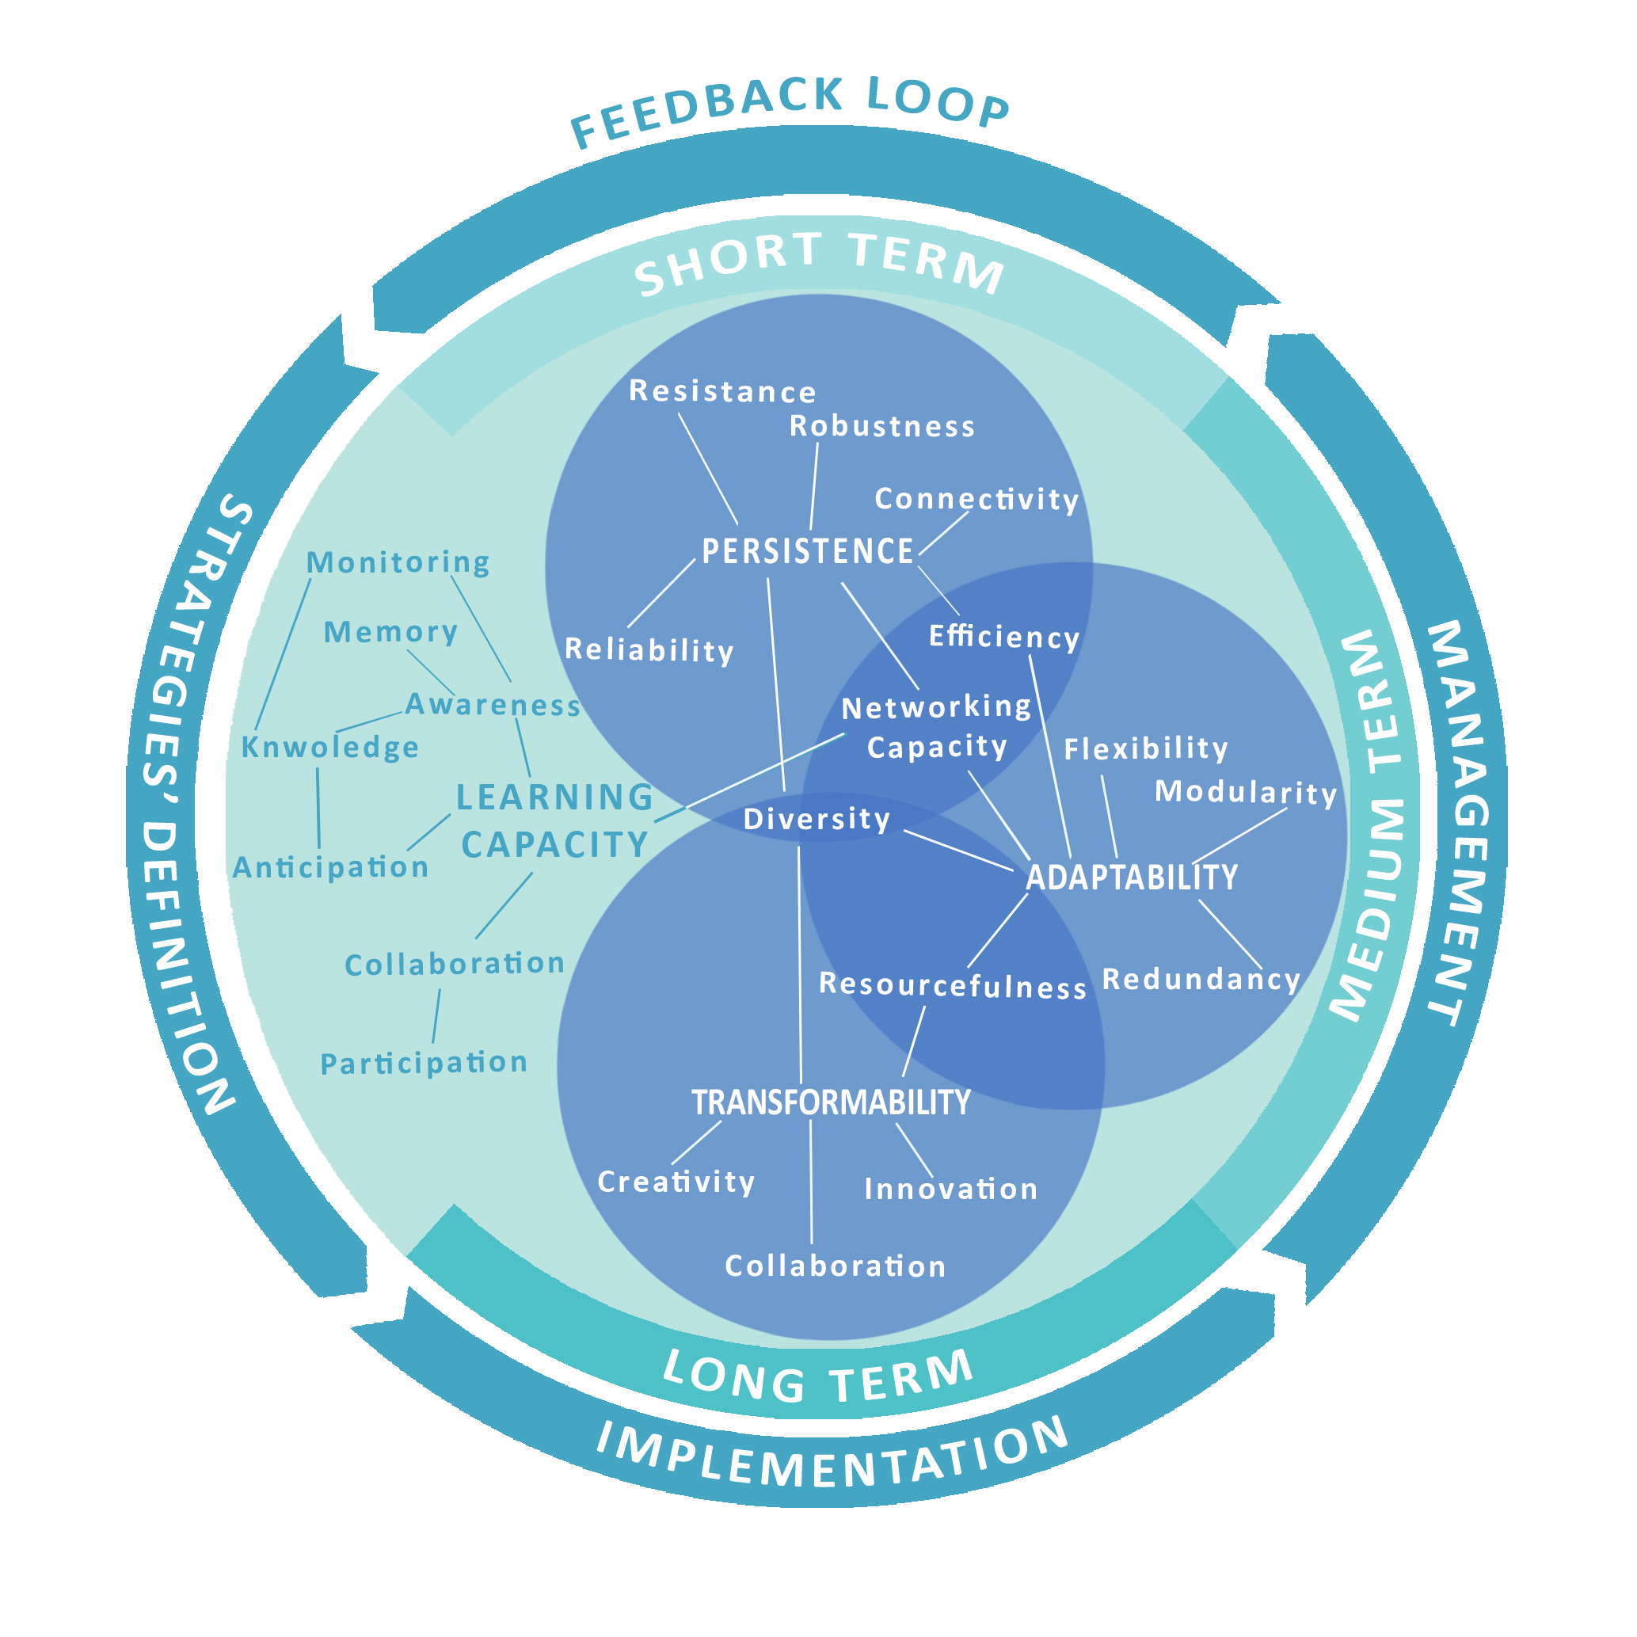
Within the model, all the selected characteristics, according to their meanings and relevance, have been hierarchized and related to one or more of the identified key properties, which are the learning capacity, the persistence, the adaptability and the transformability. Such key properties can be improved by other subordinate characteristics that can be related to more than one key properties, such as the efficiency that is common to the persistence and the adaptability. In detail, learning capacity can be improved through strategies and actions addressed to enhance: networking capacity that allows to connect people and devices for exchanging data and information; monitoring capacity, which allows to constantly detect the conditions of an urban system; knowledge that allows to elaborate information about events and processes; memory, which allows to learn from past events in order to figure out possible future scenarios; collaboration, which favors interactions and synergies between different stakeholders; participation, which allows to involve people in the decision-making processes. Moreover, learning capacity is intended crucial for developing people and institutions’ awareness about climate-related issues, to improve the capacity to anticipate likely future events, which can threaten urban systems, and, mainly grounding on monitoring and knowledge, to guarantee an effective management of the urban system along the time.

Fig. 7. The conceptual model: roles of and linkages among the capacities of a
Smart and Resilient Urban System in the face of climate change.
Finally, as emphasized above, learning capacity provides inputs for enhancing persistence, adaptability and transformation of the system in the face of climate change: these properties, which come to the fore in different temporal stages, provide in turn information that, being continuously processed, can be used as an input to further increase the learning capacity (feedback loop).
Persistence, generally referred to the ability of an urban system to maintain the characteristics and structures in the face of a threatening factor, can be improved through strategies and actions addressed to enhance: robustness, which is the ability of elements and systems to withstand a given impact without suffering degradation or loss of function (Bruneau et al., 2003); resistance that allows the urban system to not be displaced (or disturbed) by a given pressure (Carpenter et al., 2001); reliability, which is the certainty of a result (BSI, 2014); efficiency, that is the capacity to optimize the performance with modest resource consumptions (Fiksel, 2003; Aoun, 2013; Kramers et al., 2014); diversity, related to the plurality of functions and of knowledge (Berkes et al., 2002); connectivity, related to the density of links within a network and to the extent to which all the nodes of the network are accessible to each other (Janssen et al., 2006); networking capacity, which refers to the ability to create networks of non-identical elements or actors, connected by diverse interactions or links (Chuvarayan et al., 2006). In an integrated smart and resilient system, the networking capacity regards also the capacity to connect computers and devices, since the information exchange increases the urban system persistence, supporting for example the real time mobilization of resources and services where they are needed. The networking capacity is crucial also for the adaptability because it allows the creation of diverse network configurations.
Adaptability, generally related to the capacity of an urban system to adapt itself to unforeseen situations (Ratti and Townsend, 2011), can be improved through strategies and actions addressed to enhance: flexibility that, in opposition to hierarchical organizations, allows a system to be changed or adjusted to meet particular or changing needs; diversity that, recognized as crucial in case of impacts of adverse events, allows a system to better cope with uncertainty and surprise; a diverse economy ensures, for example that there is overall economic viability if one economic activity fails (Berkes et al. 2002); resourcefulness that refers to the availability of ecological, economic, social and cultural capital, allows the system to better cope with external pressures; modularity, which allows to recombine the elements of a system, supporting the transition towards different configurations; redundancy, which allows the system to count on superfluous/substitutable elements for adapting adaptable in the face of pressures; efficiency, that allows to reach optimal performances in the adapted configuration.
Finally, transformability that represents the capacity to create a fundamentally new system when ecological, political, social or economic conditions make the existing one untenable (Walker et al., 2004), can be improved through strategies and actions addressed to enhance: innovation in all elements and sectors of urban systems, from the physical to immaterial aspects, comprising the introduction of new methods, ideas, products or processes to achieve desirable outcomes (BSI, 2014); creativity, which generally results from research and experimentation that provide spurs for innovating cities in face of complex and unpredictable events; collaboration that allows to exchange new information and inputs and fosters creativity; resourcefulness, which refers to the ability to mobilize and use the available resources supporting the transition of the system towards new configurations; diversity, that allows elements to be separated and connected in new configurations.
As mentioned above, so far very few studies have attempted to combine a robust theoretical framework with operational tools.

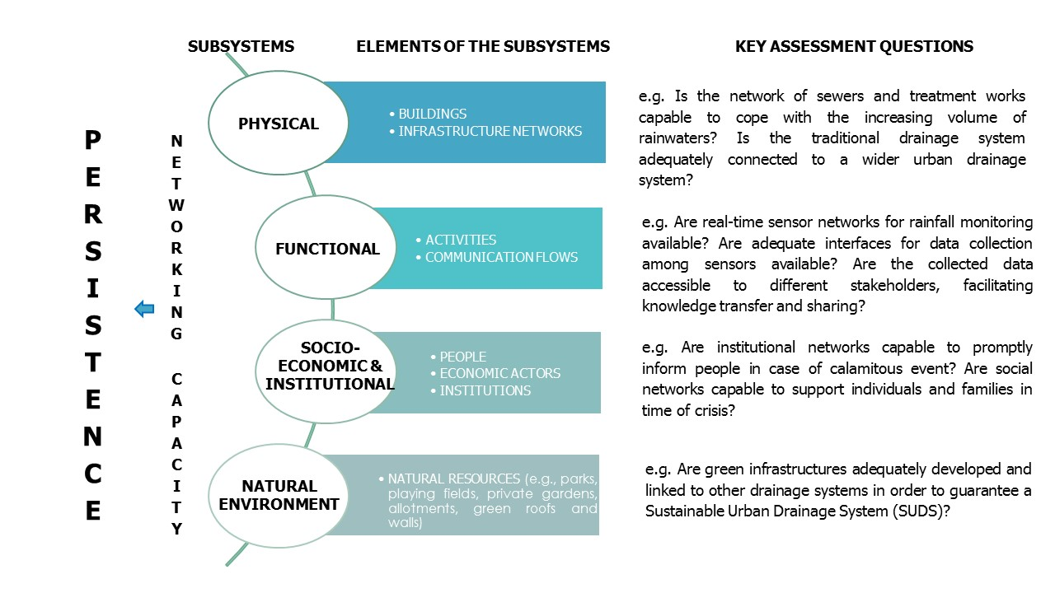 Fig. 8. Towards a guiding tool for evaluating the characteristics of a Smart and Resilient Urban System: an example related to the “networking capacity”.

The conceptual model - framing smart and resilient cities’ characteristics along the different temporal stages that characterize the dynamic process for improving cities’ capacity to deal with climate change and its impacts - provides a robust theoretical background for building up smart and resilient cities in the face of climate change. Nevertheless, an effective tool capable to guide planners and decision-makers in carrying out long, medium and short-term strategies addressed to pursue the key properties of a smart and resilient urban system in the face of climate change is still far to be achieved.
To bridge this gap, the next phase of the research work will be addressed to further develop the methodological path for guiding planners and decision makers in the assessment – with reference to the heterogeneous climate drivers and in respect to the different subsystems which constitute an urban system, physical, functional, socio-economic and institutional, natural environment (Papa et al., 2009) – of the different selected characteristics as well as in finding out the most appropriate strategies for enhancing them and monitoring their effectiveness.
An example may clarify what is meant here. According to the conceptual model, the persistence of the urban system in the face of intense rainfalls can be enhanced, by acting on different characteristics (robustness, reliability, connectivity, networking capacity, etc.). Hence, in the figure 8, an example of the methodological path for guiding planners and decision makers through the evaluation of the networking capacity of the different subsystems of an urban system, by using key assessment questions has been provided.

5 CONCLUSIONS
This study represents a first step of a wider research work addressed to develop conceptual and operational tools for improving cities’ response in the face of the heterogeneous challenges posed by the climate-related phenomena. In detail, this contribution focuses on the metaphors of “smart” and “resilient” cities that, according to current scientific literature, seem to play a leading role in enhancing cities’ capacities to cope with climate change. Based on the in-depth analysis of the current scientific literature in the field of both Smart City and Resilient City, this study has been firstly addressed to identify the main characteristics of a smart and resilient urban system. It has to be underlined that while in the resilience research field a large set of studies and researches have been focused on the characteristics of a resilient system, the Smart City literature does not provide in-depth studies on the characteristics of a smart urban system. However, some useful hints in this direction arise from the studies carried out by companies involved in the development of the Smart City standards (e.g., BIS, 2014) and from research works addressed to investigate Smart City performances (e.g., Coe, 2001; Giffinger et al., 2007; Lekamge and Marasinghe, 2013).
Then, the collected characteristics have been selected and framed into a conceptual model aimed at supporting the development of multi-objective strategies capable to improve the response capacities of complex urban systems in the face of climate change. The model is structured as a cyclical process, based on the learning capacity of urban systems and characterized by the “dynamic interplay of persistence, adaptability and transformability” (Folke et al., 2010); it outlines the temporal and operational phases that characterize the response of a complex urban system in the face of climate change, underlining roles and linkages of the different characteristics along this process, according to the different time spans (short-medium-long term). In detail, the model highlights that some characteristics (transformability) are crucial for supporting long-term strategies capable to reverse current urban development patterns in order to reduce GHG emissions and energy consumptions; others (persistence/adaptability) are relevant to short-medium term strategies aimed at enhancing cities’ capacities to withstand or adapt to the heterogeneous climate-related impacts; others (such as learning) are at the base of the process, allowing the system to start, revise or change the strategies addressed to achieve the key properties of a smart and resilient city.
Although the conceptual model provides planners and decision-makers with a robust theoretical background for building up smart and resilient cities, it represents only a preliminary step for the development of an operational tool capable to guide them in carrying out multi-objective strategies addressed to enhance the response capacities of complex urban systems in the face of climate change.
To bridge this gap, the next step of this research work will be addressed to further develop the methodological path for guiding planners and decision-makers in evaluating – with reference to the heterogeneous climate drivers and in respect to the different subsystems which constitute an urban system – the characteristics of a smart and resilient urban system, as well as in finding out adequate strategies for enhancing them and monitoring their effectiveness.

ACKNOWLEDGEMENTS
The paper is part of a wider research work developed in the framework of the “SEM Project - Smart Energy Master for the energy management of territory”, which aims at developing methods and tools for improving energy efficiency within high-density urban areas, as well as for dealing with climate change impacts and energy resources’ scarcity, through an integrated strategy capable of improving smartness and resilience of urban areas.

REFERENCES
ABB (2012). Solid Foundations for Smart Cities. White paper. Available at:http://new.abb.com/docs/default-source/smart-grids-library/abb_smart_grids_white_paper_2013.pdf?sfvrsn=2.
ABB-Ambrosetti (2012). Smart Cities in Italia: un'opportunità nello spirito del Rinascimento per una nuova qualità della vita. Available at: http://www02.abb.com/db/db0003/db002698.nsf/0/0ea1c1498ed742dec1257a700032fbc8/ $file/REPORT_ABBAmbrosetti_Completo.pdf.
ACCCRN (2012). ACCCRN City Projects Catalogue. Available at: http://www.acccrn.org/resources/documents-and-tools/2012/08/01/acccrn-city-projects-catalogue.
ACCCRN (2015). “Resilience” – an important aspect of Smart Cities. Available at: http://www.acccrn.org/news-and-events/entries/2015/01/06/resilience-%E2%80%93-important-aspect-smart-cities.
Adger, W. N., Hughes, T. P., Folke, C., Carpenter, F. C., Rockström J. (2005). Social-Ecological Resilience to Coastal Disasters. Science 12 August 2005. Vol. 309 no. 5737 pp. 1036-1039. DOI: 10.1126/science.1112122.
Ahern, J. (2011). From fail-safe to safe-to-fail: sustainability and resilience in the new urban world. Landscape and Urban Planning, 100, 341-343
Alberti M., Marzluff J. M., Shulenberger E., Bradley G., Ryan C., Zumbrunnen C. (2003). Integrating Humans into Ecology: Opportunities and Challenges for Studying Urban Ecosystems. BioScience 53:1169-1179.
Alexander, D.E. (2013), “Resilience and disaster risk reduction: an etymological journey”, Natural Hazards and Earth System Science, 13, 2707–2716. www.nat-hazards-earth-syst-sci.net/13/2707/2013/ doi:10.5194/nhess-13-2707-2013
Aoun, C. (2013). The Smart City Cornerstone: Urban Efficiency. Schneider Electric White Paper. Available at: http://www.digital21.gov.hk/sc/relatedDoc/download/2013/079%20SchneiderElectric%20%28Annex%29.pdf.
Auge Blùm, I., Boussetta, K., Rivano, H., Stanica, R., Valois, F. (2012). Capillary Networks: A Novel Networking Paradigm for Urban Environments. Proceedings of UrbaNE’12, December 10, 2012, Nice, France. Available at: http://conferences.sigcomm.org/co-next/2012/eproceedings/urbane/p25.pdf.
Bahadur, A. V., Ibrahim, M., Tanner, T. (2010). The resilience renaissance? Unpacking of resilience for tackling climate change and disasters. Strengthening Climate Resilience Discussion. Paper 1, Brighton: IDS. Available at: http://community.eldis.org/.59e0d267/resilience-renaissance.pdf.
Bankoff, G., Frerks, G., Hilhorst, D. (2004). Mapping vulnerability. Disasters, development and people. Earthscan, London.
Batty, M. (2008). Cities as Complex Systems. Scaling, Interactions, Networks, Dynamics and Urban Morphologies. Working Papers Series, Paper 131, Centre for Advanced Spatial Analysis, University College London, ISSN 1467-1298. http://discovery.ucl. ac.uk/15183/1/15183.pdf
Batty, M., Axhausen, K. W., Giannotti, F., Pozdnoukhov, A., Bazzani, A., Wachowicz, M., Ouzounis, G., Portugali, Y. (2012). Smart City of the Future. The European Physical Journal - Special Topics 214, 481–518.
Bencardino, M., Greco, I. (2014). Smart Communities. Social Innovation at the Service of the Smart Cities. TeMa, Journal of Land Use, Mobility and Environment. Special Issue.
Berkes, F., Colding, J., Folke, C. (2003). Navigating Social-Ecological Systems: Building Resilience for Complexity and Change. Cambridge University Press, Cambridge.
Birkmann, J., Garschagen, M., Kraas, F. (2010). Adaptive urban governance: new challenges for the second generation of urban adaptation strategies to climate change. Sustainable Science 5(2):185-206. http://ihdp.unu.edu/file/get/10637.pdf.
Brand, F.S., Jax, K. (2007). Focusing the Meaning(s) of Resilience: Resilience as a Descriptive Concept and a Boundary Object. Ecology and Society 12(1): 23.
BSI (2013). Smart Cities: background paper. British Standards Institution. ISBN: 978 0 580 81874 5. Available at: https://www.gov.uk/government/uploads/system/uploads/attachment_data/file/246019/bis-13-1209-smart-cities-background-paper-digital.pdf.
BSI (2014). PAS 180, Smart cities – Vocabulary. British Standards Institution.
Brundtland Report (1987). Our common future. World Commission on Environment and Development (WCED). Oxford: Oxford University Press, 1987 p. 43.
Bruneau, M., Chang, S.E., Eguchi, R. T., Lee, G. C., O’Rourke, T. D., Reinhorn, A. M., Shinozuka, M., Tierney, K., Wallace, W. A., von Winterfeldt, D. (2003). A Framework to Quantitatively Assess and Enhance the Seismic Resilience of Communities. Earthquake Spectra, 19(4), 733–752.
Caragliu, A., Nijkamp, P. (2008). The impact of regional absorptive capacity on spatial knowledge spillovers. Tinbergen Institute Discussion Papers 08-119/3, Amsterdam: Tinbergen Institute.
Caragliu, A., Del Bo, C., Nijkamp, P. (2009). Smart cities in Europe. Proceedings of the 3rd Central European Conference in Regional Science (Košice, Slovak Republic, Oct 7-9). Available at: http://www.cers.tuke.sk/cers2009/PDF/01_03_Nijkamp.pdf.
Carpenter, S.R., Walker, B.H., Anderies, J.M. and Abel, N. (2001), From metaphor to measurement. Resilience of what to what? Ecosystems 4: 765-781.
Chelleri, L., Kunath, A., Minucci, G., Olazabal, M., Waters, J. J., Yumalogava, L. (2012). Multidisciplinary perspective on urban resilience. Workshop report. BC3, Basque Centre for Climate Change. ISBN: 978-84-695-6025-9. Available at: http://www.bc3research.org/multidisciplinary_perspectives_on_urban_resilience.
Chen, J., Chen, T. H. Y., Vertinsky, I., Yumagulova, L. and Park, C. (2013). Public–Private Partnerships for the Development of Disaster Resilient Communities. Journal of Contingencies and Crisis Management, 21: 130–143. doi: 10.1111/1468-5973.12021.
Chourabi, H., Taewoo Nam, Walker S., Gil-Garcia J.R. ; Mellouli S., Nahon K., Pardo, T.A., Scholl H. J. (2012). Understanding Smart Cities: An Integrative Framework. 45th Hawaii International Conference on System Sciences. 978-0-7695-4525-7/12 $26.00 © 2012 IEEE. DOI 10.1109/HICSS.2012.615.
Chuvarajan A., Martel I., Peterson C. (2006). A Strategic Approach for sustainability and resilience planning within municipalities. Thesis submitted for completion of Master of Strategic Leadership towards Sustainability, Blekinge Institute of Technology, Karlskrona, Sweden.
CIAT (2015). Report for Cities Impacts & Adaptation Tool. Climate Center, University of Michigan. Available at: http://graham-maps.miserver.it.umich.edu/ciat/report.xhtml.
Coe A., Paquet G., Roy J. (2001). E-Governance and Smart Communities: A Social Learning Challenge. Social Science Computer Review 2001; 19; 80.
Cohen, B. (2012). The top 10 smartest European cities. Available at: http://smartertrends.co.uk/articles/2012-11-14/the-top-10-smartesteuropeancities/original/?original=www.fastcoexist.com/1680856/the-top-10-smartest-european-cities
Colucci A. (2012). Le città resilienti: approcci e strategie. Monografia, Jean Monnet Centre of Pavia. Available at: http://www.jeanmonnet-pv.it/Jean_Monnet_Centre_of_Excellence/publications_files/full_txt_colucci_jm.pdf.
Cretu L. G. (2012). Smart Cities Design using Event-driven Paradigm and Semantic Web. Informatica Economică vol. 16, no. 4/2012. Available at: http://www.revistaie.ase.ro/content/64/07%20-%20Cretu.pdf.
Cutter S.L., Barnes L., Berry M., Burton C., Evans E., Tate E., Webb J. (2008), “A place-based model for understanding community resilience to natural disasters”, Global Environmental Change, 18:598-606.

Dameri R. P. (2013). Searching for Smart City definition: a comprehensive proposal, International Journal of Computers & Technology. Vol 11, No.5. October 25, 2013. PP. 2544-2551.
Davoudi S. (2012). Resilience: A Bridging Concept or a Dead End?. Planning Theory and Practice 2012, 13(2), 299-307.
Davoudi S., Brooks E., Mehmood A. (2013), “Evolutionary Resilience and Strategies for Climate Adaptation”, Planning Practice & Research, 28:3, 307-322. http://dx.doi.org/10. 1080/02697459.2013.787695
Da Silva J., Kernaghan S., Luque A. (2012). A systems approach to meeting the challenges of urban climate change. International Journal of Urban Sustainable Development, 4(2), 125–145.
Deakin M. (2012). Smart Cities: Governing, Modelling and Analysing the Transition. Routledge, 2012.
Dirks S., Gurdgiev C., Keeling, M. (2010). Smarter cities for smarter growth. How cities can optimize their systems for the talent-based economy. IBM Global Business Services. Executive Report.
Drobniak A. (2010). The Urban Resilience – Economic Perspective. Journal of Economics & Management. Vol. 10/2012. University od Economics in Katowice.
EEA (2012). Urban adaptation to climate change in Europe - Challenges and opportunities for cities together with supportive national and European policies. EEA Report No 2/2012. ISBN: 978-92-9213-308-5. Available at: http://www.eea.europa.eu/publications/urban-adaptation-to-climate-change.
EEA (2014). Report of the EEA Scientific Committee Seminar on Environment, Human Health and Well-Being. Advancing the Knowledge Base. Summary of discussion at the European Environment Agency’s Scientific Committee Seminar on 12 February 2014 in Copenhagen. Available at: http://www.eea.europa.eu/about-us/governance/scientific-committee/reports/report-of-the-eea-scientific.
Eger J. M. (2009). Smart Growth, Smart Cities, and the Crisis at the Pump A Worldwide Phenomenon. I-WAYS - The Journal of E-Government Policy and Regulation. Volume 32 Issue 1, January 2009. Pages 47-53.
EIP - European Innovation Partnership on Smart Cities and Communities (2013). Available at: http://ec.europa.eu/energy/technology/initiatives/doc/2012_4701_smart_cities_en.pdf.
EIP - European Innovation Partnership on Smart Cities and Communities (2014). Available at: http://eu-smartcities.eu/content/show-world-you-are-smart-city.
Elmqvist, T. (2013). How Smart is a Smart City? Presentation at the Switched on Nature Seminar. Available at: http://www.stockholmresilience.org/5.2f48c3c31429b6ad0a61192.html.
ENSURE (2012). Integration of different vulnerabilities vs. Natural and Natech Hazards. Deliverable 2.2 of the Enhancing resilience of communities and territories facing natural and na-tech hazards Project.
Ercoskun, O.Y. (2012). A Paradigm Shift towards Urban Resilience. Green and Ecological Technologies for Urban Planning: Creating Smart Cities. IGI Global, 2012. 1-16. Web. 19 Jan. 2015. doi:10.4018/978-1-61350-453-6.ch001.
Ernstson, H., van der Leeuw, S., Redman, C.L., Meffert, D.J., Davis, G., Alfsen, C., Elmqvist, T. (2010). Urban transitions: on urban resilience and human-dominated ecosystems. AMBIO: A Journal of the Human Environment, pages 1–15.
EU (2009). Adapting to climate change: Towards a European framework for action. White Paper. Available at: http://eur-lex.europa.eu/legal-content/EN/TXT/PDF/?uri=CELEX:52009DC0147&from=EN.
EU (2011). Cities of tomorrow. Challenges, visions, ways forward. European Union, 2011. ISBN: 978-92-79-21307-6. doi:10.2776/41803. Available at: http://ec.europa.eu/regional_policy/sources/docgener/studies/pdf/citiesoftomorrow/citiesoftomorrow_final.pdf.
EU (2013). An EU Strategy on adaptation to climate change. Available at: http://eur-lex.europa.eu/legal-content/EN/TXT/PDF/?uri=CELEX:52013DC0216&from=EN.
EU LIFE (2014). Urban Resilience - LIFE+ projects and European policies. 4-5 April 2014, Colombes, FR. Summary Report. Available at: http://ec.europa.eu/environment/life/news/newsarchive2014/documents/report-urbanresilience.pdf.
Fiksel, J. (2003). Designing resilient, sustainable systems. Environmental Science & Technology, 37(23), 5330–5339
Florida, R. (2003). Cities and the Creative Class. City and Communities. Volume 2, Issue 1, pages 3–19.
Folke, C., Carpenter, S., Elmqvist, T., Gunderson L., Holling C.S., Walker, B. (2002). Resilience and Sustainable Development: Building Adaptive Capacity in a World of Transformations. Ambio Vol. 31 No. 5.
Folke, C., Hahn, T., Olsson, P., Norberg, J. (2005). Adaptive Governance for Social-Ecological System. Annu. Rev. Environ. Resour. 30:441-73
Folke, C. (2006). Resilience: The Emergence of a Perspective for Social-Ecological Systems Analyses, in Global Environmental Change 16: 253–67.
Folke, C., Carpenter, S.R., Walker, B., Scheffer, M., Chapin, T., Rockstrom, J. (2010) “Resilience Thinking: integrating Resilience, Adaptability and Transformability”, Ecology and Society, 15(4):20. http://www.ecologyandsociety.org/vol15/iss4/art20/
Fusco Girard, L., Baycan, T., Nijkamp, P. (2012). The Creative City in a Multidimensional Perspective. Chapter of “Sustainable City and Creativity: Promoting Creative Urban Initiatives”. Ashgate Publishing, Ltd.
Füssel, H.-M., Klein, R. J. T. (2006). Climate Change Vulnerability Assessments: An Evolution of Conceptual Thinking. Climatic Change, 75(3), 301–329
Galderisi, A., Ferrara, F.F. (2012). Enhancing Urban Resilience In Face Of Climate Change, TeMa, Journal of Land Use, Mobility and Environment. Vol. 2, 69-87. DOI: 10.6092/1970-9870/936
Galderisi, A. (2013). Un modello interpretativo della resilienza urbana. PLANUM, the Journal of Urbanism. ISSN 1723-0993 | no. 27, vol. II [2013].
Galderisi, A. (2014). Climate Change Adaptation. Challenges and Opportunities for a Smart Urban Growth. TeMa, Journal of Land Use, Mobility and Environment. Vol.7, n.1.
Gibson, D.V., Kozmetsky, G., Smilor, R.W. (eds.) (1992), The Technopolis Phenomenon: Smart Cities, Fast Systems, Global Networks, Rowman & Littlefield, New York.
Giffinger, R., Fertner, C., Kramar, H., Kalasek, R., Pichler-Milanović, N., Meijers, E. (2007). Smart Cities: Ranking of European Medium-Sized Cities. Vienna, Austria: Centre of Regional Science (SRF), Vienna University of Technology. Available at: http://www.smartcities.eu/download/smart_cities_final_report.pdf.

Glaeser, E.L., Berry, C.R. (2006). Why Are Smart Places Getting Smarter?. Taubman Cente Policy Brief 2006-2, Cambridge MA: Taubman Centre.
Godschalk, D.R. (2003). Urban Hazard Mitigation: Creating Resilient Cities. Natural Hazards Review, ASCE, August. DOI: 10.1061/~ASCE!1527-6988~2003!4:3~136!
Gunderson, L. (2010). Ecological and human community resilience in response to natural disasters. Ecology and Society 15(2): 18.
Hall, R. E. (2000). The vision of a smart city. In Proceedings of the 2nd International Life Extension Technology Workshop, Paris, France, September 28.
Hallegatte, S. (2009). Strategies to adapt to an uncertain climate change. Global Environmental Change 19 (2009) 240–247.
Heeks, R., Ospina, A. V. (2013). Understanding Urban Climate Change and Digital Infrastructure Interventions from a Resilience Perspective. Centre for Development Informatics. ISBN: 978-1-905469-77-2.
Heylighen, F. (2008), “Complexity and Self-organization”, in Bates M.J. and Maack N., eds., Encyclopedia of Library and Information Sciences, Taylor & Francis.
Hollands, R. G. (2008). Will the real smart city please stand up?. City: analysis of urban trends, culture, theory, policy, action. Volume 12, Issue 3, 2008. DOI: 10.1080/13604810802479126
Holling, C.S. (1973). Resilience and stability of ecological systems. Annu. Rev. Ecol. Syst. 4:1–23.
Holling, C.S. (1996), “Engineering resilience versus Ecological resilience”, in P. Schulze (ed.), Engineering with ecological constrains, National Academy, Washington, D.C., USA.
Hopkins, R. (2008). The transition handbook: from oil dependency to local resilience. Green Books, Totnes, Devon, UK. ISBN: 9781900322188
ICLEI (2014a). Available at: http://resilient-cities.iclei.org/resilient-cities-hub-site/resilience-resource-point/glossary-of-key-terms/.
ICLEI (2014b). How does the Urban NEXUS Approach and inter-sectoral coordination make cities more resilient? A.3. SESSION DESCRIPTION – 5TH Global Forum on Urban Resilience & Adaptation. Bonn, Germany 29-31 May 2014.
IFRC - International Federation of Red Cross and Red Crescent Society (2011). Characteristics of a Safe and Resilient Community. Community Based Disaster Risk Reduction Study. Available at: http://www.ifrc.org/PageFiles/96986/Final_Characteristics_Report.pdf.
IPCC (2012), Special Report on Managing the Risks of Extreme Events and Disasters to Advance Climate Change Adaptation, Cambridge University Press, Cambridge, UK, New York, USA. http://ipcc-wg2.gov/SREX/images/uploads/SREX-All_FINAL.pdf
IPCC (2013). Climate Change 2013: The Physical Science Basis. Contribution of Working Group I to the Fifth Assessment Report of the Intergovernmental Panel on Climate Change. Cambridge University Press, Cambridge, United Kingdom and New York, NY, USA, 1535 pp. Available at: http://www.climatechange2013.org/images/report/WG1AR5_ALL_FINAL.pdf
IPCC (2014). Climate Change 2014: Mitigation of Climate Change. Contribution of Working Group III to the Fifth Assessment Report of the Intergovernmental Panel on Climate Change. Cambridge University Press, Cambridge, United Kingdom and New York, NY, USA.
ISO/IEC (2014). Smart Cities. Preliminary Report 2014. ISO/IEC JTC 1, Information technology. Available at: http://www.iso.org/iso/smart_cities_report-jtc1.pdf.
ITU (2014). United Nations specialized agency for information and communication technologies – Focus Group on Smart Sustainable Cities. Available at: http://www.itu.int/en/ITU-T/focusgroups/ssc/Pages/default.aspx.
Jabareen, Y. (2013). Planning the resilient city: Concepts and strategies for coping with climate change and environmental risk. Cities 31 (2013) 220–229.
Janssen, M. A., Bodin, Ö., Anderies, J. M., Elmqvist, T., Ernstson, H., McAllister, R. R. J., Olsson, P., Ryan, P. (2006). Toward a network perspective on the resilience of social-ecological systems. Ecology and Society 11(1): 15.
Jerneck, A., Olsson, L. (2008). Adaptation and the Poor: Development, Resilience and Transition. Climate Policy, 8(2): 170–82.
Kahan, J. H., Allen A. C., George, J. K. (2009). An operation framework for resilience. Journal of Homeland Security and Emergency Management. Volume 6, Issue 1. 2009. Article 83.
Kallaos J., Mainguy G., Wyckmans A. (2014). Considering Resilience: steps towards an assessment framework. TeMa, Journal of Land Use, Mobility and Environment. Vol.5, n.27.
Karnouskos S., Da Silva P. G., Ilic D. (2013). Energy Services for the Smart Grid City. Digital Ecosystems Technologies (DEST), 6th IEEE International Conference.
Klein R.J.T., Nicholls R.J., Thomalla F. (2003). Resilience to natural hazards: How useful is this concept? Global Environmental Change Part B: Environmental Hazards. Volume 5, Issues 1–2, 2003, Pages 35–45.
Klein, R.J.T., Schipper, E. L., Dessai, S. (2005). Integrating mitigation and adaptation into climate and development policy: three research questions. Environmental Science & Policy 8: 579–588. Available at: http://www.unisdr.org/files/1140_sdarticle.pdf.
Kramers A., Höjer M., Lövehagen N., Wangel J. (2014). Smart sustainable cities e Exploring ICT solutions for reduced energy use in cities. Environmental Modelling & Software.
Kuhn T.S. (1970). The Structure of Scientific Revolutions. International Encyclopedia of Unified Science, Foundations of the Unity of Science, Volume II, Number 2. Available at: http://projektintegracija.pravo.hr/_download/repository/Kuhn_Structure_of_Scientific_Revolutions.pdf.
Kunzmann K.R (2014). Smart Cities: A New Paradigm of Urban Development. Crios, 1/2014, pp. 9-20, doi: 10.7373/77140.
Lazaroiu G. C., Roscia M. (2012). Definition methodology for the smart cities model. Energy 47 (2012) 326-332. doi:10.1016/j.energy.2012.09.028.
Lee J.H., Phaal R., Lee S. H. (2013). An integrated service-device-technology roadmap for smart city development. Technological Forecasting and Social Change 80, 286–306. doi:10.1016/j.techfore.2012.09.020.
Lekamge S., Marasinghe A. (2013). Developing a Smart City Model that Ensures the Optimum Utilization of Existing Resources in Cities of All Sizes. Biometrics and Kansei Engineering (ICBAKE), 2013 International Conference, pp.202-207, 5-7 July 2013. doi: 10.1109/ICBAKE.2013.40.
Lombardi P. (2011). Managing the green IT agenda. Intelligent Buildings International Vol. 3, Iss. 1.
Longstaff P. H., Armstrong N. J., Keli P., Parker W. M., Hidek M. (2010). Building Resilient Communities - A Preliminary Framework for Assessment. Homeland Security Affairs, VI (3).
Low B., Ostrom E., Simon C., Wilson J. (2000). Redundancy and diversity in governing and managing common-pool resources. 8th Biennial conference of the International Association for the Study of Common Property (IASCP), Indiana University, Bloomington, Indiana, May 31-June 4, 2000.
Maguire B., Hagan P. (2007). Disasters and communities: Understanding social resilience. The Australian Journal of Emergency Management, Vol. 22 No. 2.
Martin-Breen P., Anderies J. M. (2011). Resilience: A Literature Review. Rockefeller Foundation Report. Available at: http://www.rockefellerfoundation.org/blog/resilience-literature-review.
McIntosh R.J., Tainter J. A., McIntosh S. K. (2000). The Way the Wind Blows: Climate, History and Human Action. Columbia University Press.
McMahon K. (2014). Smart Cities and Broadband. Broadband Communities. Available at: http://www.bbcmag.com/2014mags/Nov_Dec/BBC_Nov14_SmartCities.pdf.
Moccia F. D. (2012). Smart city: etimologia del termine. Un'analisi firmata INU. Available at: http://admin.edilio.it/smart-city-etimologia-del-termine-un-analisi-firmata-inu/p_19560.html.
Moir E., Moonen T., Clark G. (2014). What are future cities? Origins, meanings and uses. Available at: https://www.gov.uk/government/uploads/system/uploads/attachment_data/file/337549/14-820-what-are-future-cities.pdf.
Mosannenzadeh F., Vettorato D. (2014). Defining Smart City: a conceptual framework based on keyword analysis. TeMa, Journal of Land Use, Mobility and Environment. Special Issue.
Moser M. A. (2001). What is Smart about the Smart Communities Movement?. EJournal Volume 10-11 Number 1 (March 2001). Available at: http://www.ucalgary.ca/ejournal/archive/v10-11/v10-11n1Moser-print.html#Smart Economic Strategies.
Moser C., Wendel T., Carabias-Hütter V. (2014). Scientific and Practical Understandings of Smart Cities. Proceedings REAL CORP 2014 Tagungsband 21-23 May 2014, Vienna, Austria.
Naphade M., Banavar G., Harrison C., Paraszczak J., Morris R. (2011). Smarter Cities and Their Innovation Challenges. 0018-9162/11/$26.00 © 2011 IEEE Computer Society.
Nam T., Pardo T. A. (2011). Conceptualizing Smart City with Dimensions of Technology, People, and Institutions. The Proceedings of the 12th Annual International Conference on Digital Government Research. ACM, pp. 282–291.
Navarrete L. C., Dalmas S. ,Varas F. J., Fayos A., Busto F.J. (2012). Social Open Data to harness the empowerment of Smart Community. Available at: http://eu-smartcities.eu/sites/all/files/docs/best-practice/Social%20Open%20DAta%20to%20harness%20the%20empowerment%20of%20Smart%20Community%20.pdf
New City Foundation (2014).Beyond the Smart City: Towards a New Paradigm. Available at: http://www.newcitiesfoundation.org/.
Newman P., Beatley T., Boyer H. (2009). Resilient Cities: Responding to Peak Oil and Climate Change. Island Press, 2009. ISBN: 1597268631.
North P. (2010). Eco-localisation as a progressive response to peak oil and climate change – A sympathetic critique. Geoforum 41 (2010) 585–594.
Norris F., Stevens S., Pfefferbaum B., Wyche K., Pfefferbaum R. (2008), Community resilience as a metaphor, theory, set of capacities, and strategy for disaster readiness, American Journal of Community Psychology, vol. 41.
Papa R., Battarra R., Calenda C., Cerrone D., Ceudech A., Fistola R., Galderisi A., Gargiulo C., La Rocca R.A., Mazzeo G., Papa E. (2009). Il governo delle trasformazioni urbane e territoriali. Metodi, tecniche e strumenti. Franco Angeli Editore, pp. 560. ISBN: 9788856811476.
Papa R., Galderisi A., Gargiulo C. (2013). Towards an Urban Planners’ Perspective on Smart City. TeMa, Journal of Land Use, Mobility and Environment. Vol. 6, n.1.
Partridge H. (2004). Developing a Human Perspective to the Digital Divide in the Smart City. In Partridge, Helen (Ed.)Australian Library and Information Association Biennial Conference, 21-24 September 2004, Gold Coast, Queensland, Australia.
Paskaleva K. A. (2009). Enabling the smart city: the progress of city e-governance in Europe. International Journal of Innovation and Regional Development. Volume 1, Number 4/2009. Pages 405-422.
Pellegrini P. (2003). Smart Growth Movement, lo scenario emergente. Tesi di dottorato presentata nel giungno 2003. Pubblicata da Università IUAV di Venezia. IUAV Digital LIbrary © settembre 2011. ISBN 978-88-87697-59-9. Available at: http://rice.iuav.it/270/3/cap_2_smart_growth.pdf.
Pickett S.T.A., Cadenasso M.L., Grove J.M. (2004). Resilient cities: meaning, models, and metaphor for integrating the ecological, socio-economic, and planning realms. Landscape and Urban Planning 69 (2004) 369–384.
Pickett S.T.A., Boone C. G., McGrath B. P., Cadenasso M. L., Childers D. L., Ogden L. A., McHale M., Grove J. M. (2013). Ecological science and transformation to the sustainable city, Cities.
Ratti C., Townsend A. ( 2011). The Social Nexus. Scientific American, September 2011. Available at: http://senseable.mit.edu/papers/pdf/2011_Ratti_Townsend_Nexus_SA.pdf.
Redman C. L. (2014). Should sustainability and resilience be combined or remain distinct pursuits?. Ecology and Society 19(2): 37. http://dx.doi.org/10.5751/ES-06390-190237.
Resilient City (2014). Available at: http://www.resilientcity.org/index.cfm?id=11449.
Rose A. (2007). Economic resilience to natural and man-made disasters: multidisciplinary origins and contextual dimensions. Environmental Hazards, Volume 7, Issue 4, 2007, Pages 383-398, ISSN 1747-7891.
Roeckefeller Foundation (2014). Available at: http://www.rockefellerfoundation.org/our-work/current-work/resilience.
Rockefeller Foundation (2015). Available at: http://www.100resilientcities.org/cities#/-_/.
Rogers C. D. F., Bouch C.J., Williams S., Barber A.R.G., Baker C.J., Bryson J.R., Chapman D.N., Chapman L., Coaffee J., Jefferson, I. and Quinn A.D. (2012). Resistance and Resilience – two paradigms for critical local infrastructure. Proceedings of the ICE - Municipal Engineer, Volume 165, Issue 2, 01 June 2012 ,pages 73 –83.
Sapountzaki K. (2010). Vulnerability management by means of resilience. Natural Hazards: Journal of the International Society for the Prevention and Mitigation of Natural Hazards. ISSN 0921-030X. Nat Hazards. DOI 10.1007/s11069-011-9908-3
Schultz M. T., McKay S. K., Hales L. Z. (2012). The Quantification and Evolution of Resilience in Integrated Coastal Systems (No. ERDC TR-12-7). Washington, DC: U.S. Army Corps of Engineers (USACE) Engineer Research and Development Center (ERDC).
Simmie J., Martin R. (2010). The economic resilience of regions: towards an evolutionary approach. Cambridge Journal of Regions, Economy and Society 2010, 3, 27–43. doi:10.1093/cjres/rsp029
Smart City Council (2014a). Available at: http://smartcitiescouncil.com/article/next-decade-bring-fourfold-increase-number-smart-cities.
Smart Cities Council (2014b). Smart Cities Readiness Guide. Available at: http://smartcitiescouncil.com/resources/smart-cities-readiness-guide.
Sovacool B. K. (2011). Hard and soft paths for climate change adaptation. Climate Policy 11 (2011) 1177–1183. doi:10.1080/14693062.2011.579315.
Stacey R., Griffin D., Shaw P. (2000). Complexity and management: Fad or Radical Challenge to Systems Thinking? Routledge, London and New York.
STERIA (2011). Smart Cities will be enabled by Smart IT. Available at: http://www.steria.com/fileadmin/com/sharingOurViews/publications/files/STE3899-Smart_Cities_brochure_08_APP.PDF.
Stockholm Resilience Centre (2014). Applying resilience thinking. Seven principles for building resilience in social-ecological systems. Available at: http://www.stockholmresilience.org/21/research/research-news/4-22-2014-applying-resilience-thinking.html.
Suppe F. (1977). Elements of Scientific Theories: Concepts and Definitions, Chapter 2 of “The structure of scientific theories”, second edition.
Tasan-Kok T., van Kempen R., Raco M., Bolt G. (2013). Conceptual Overview of Resilience: history and context. Resilience Thinking in Urban Planning. GeoJournal Library 106. pp. 39-52.
Toppeta D. (2010). The Smart City vision: how innovation and ICT can build smart, “liveable”, sustainable cities. THINK! REPORT 005/2010. Available at: http://www.inta-aivn.org/images/cc/Urbanism/background%20documents/Toppeta_Report_005_2010.pdf.
TURAS (2012). Urban Transformations: Integrating social-ecological resilience thinking into urban planning and governance. Transitioning towards urban resilience and sustainability project. Available at: http://www.turas-cities.org/uploads/biblio/document/file/213/WP3_Lit_Rev_Section_01_.pdf.
Tyler S., Moench S. (2012). A framework for urban climate resilience. Climate and Development. Vol. 4, No. 4, October 2012, 311–326
UN (2014). Population Division World Urbanization Prospects. The 2014 Revision, Highlights. Department of Economic and Social Affairs.
UNEP (2014). Climate Finance for Cities and Buildings - A Handbook for Local Governments. UNEP Division of Technology, Industry and Economics (DTIE), Paris. Available at: www.unep.org/publications.
UNISDR (2012a). Available at: http://www.unisdr.org/campaign/resilientcities/about.
UNISDR (2012b). How to make cities more resilient – A Handbook For Local Government Leaders. Available at: http://www.unisdr.org/we/inform/publications/26462.
Vale, L., Campanella, T.H. (2005). The resilient city: How modern cities recover from disaster. New York: OxFord University Press.
Viitanen, J., Kingston, R. (2014). Smart cities and green growth: outsourcing democratic and environmental resilience to the global technology sector. Environment and Planning A 2014, volume 46, pages 803 – 819. doi:10.1068/a46242
Wagener, W. (2008). Connected and Sustainable ICT Infrastructure. Cisco Internet Business Solutions Group. Report written specifically for Connected Urban Development Global Conference 2008—Amsterdam. Available at: http://www.cisco.com/web/about/ac79/docs/wp/ctd/connected_infra.pdf.
Walker, B., Holling C. S., Carpenter S. R., Kinzig A. (2004). Resilience, adaptability and transformability in social–ecological systems. Ecology and Society 9(2): 5.
Walker B., Salt B. (2006), Resilience thinking: sustaining ecosystems and people in a changing world. Washington, DC: Island Press.
Washburn D., Sindhu U. (2011). Helping CIOs Understand “Smart City” Initiatives. Defining The Smart City, Its Drivers, And The Role Of The CIO. Forrester Research Report. Available at: http://www.itworldcanada.com/archive/Themes/Hubs/Brainstorm/forrester_help_cios_smart_city.pdf.
Wolfram M. (2012). Deconstructing Smart Cities: An Intertextual Reading of Concepts and Practices for Integrated Urban and ICT Development. Proceedings REAL CORP 2012 Tagungsband 14-16 May 2012, Schwechat.
World Bank Group (2011). Guide to Climate Change Adaptation in Cities. Available at: http://siteresources.worldbank.org/INTURBANDEVELOPMENT/Resources/336387-1318995974398/GuideClimChangeAdaptCities.pdf.
Zani B. (2012). Empowerment: analisi di un costrutto "intrigante", in: Psicologia di Comunità. Prospettive, Idee, Metodi. ROMA, CAROCCI, 2012, pp. 135 – 162.
IMAGE SOURCES
Cover image: http://pixabay.com/en/rotterdam-erasmus-bridge-stadt-269281/
Fig. 1, 5, 6, 7, 8: figures are from authors
Fig. 2, 3, 4: figures are from Google Trends
AUTHORS’ PROFILE
Rocco Papa

Full Professor of Land Use Planning at the University of Naples Federico II. Editor-in-Chief of the Scientific Journal TeMA - Land Use, Mobility and Environment since 2007. Director of the Department of Urban and Regional Planning (DiPiST) of the University Federico II of Naples, from 1999 to 2005. Chairman of the Urban Transformation Company Bagnolifutura S.p.A from 2006 to 2010. Vice-Mayor of the Municipality of Naples, from 2001 to 2006. City Councilor for Livability (appointed to Town Planning and Historical Centre) for the Naples Municipality, from 1997 to 2001. Research activity, carried out continuously since 1974, has developed according to the following four main lines: the study of the interactions between urban and mobility systems; the management and governance of metropolitan areas; the safeguard of environmental quality in highly urbanized areas; the experimentation of new protocols for urban planning tools connected with the updating of techniques, methods and models of analyses, interpretation, planning and governance of territory. As City Councilor for Livability (appointed to Town Planning and Historical Centre) for the Naples Municipality he has developed in detail the following projects: the approval and implementation of the new Master Plan of Naples; the approval and implementation of the Local Master Plan for the area of Bagnoli-Coroglio and the establishment of the Urban Transformation Company Bagnolifutura SpA, and the restoration and requalification of the “Real Albergo dei Poveri” and of the “SS. Trinità delle Monache”, the implementation of the Line 1 and Line 6 of the Metropolitan Railway. He is the author of more than 100 publications.
Adriana Galderisi
Assistant Professor at the Department of Civil, Architectural and Environmental Engineering - University of Naples Federico II. Ph.D. in Urban and Regional Planning; Professor of Urban and Regional Planning at the University of Naples Federico II. Research activities are mainly focused on the urban environment requalification and namely on two issues: the relationships between land use planning, mobility and environmental issues; vulnerability and resilience of urban systems to natural and na-tech events. In respect to the latter, she has coordinated research teams within numerous National and European Projects from 2000 to 2008. From 2008 to 2011, she has been the Scientific Responsible for the European Project “ENSURE - Enhancing resilience of communities and territories facing natural and na-tech hazards” (7° Framework Programme - Theme 6 Environment - Topic 6.1.3.2.1 Frame for better vulnerability assessment). From 2012, she is the Responsible for the Training Project of the National Project “Smart Energy Master for the energy management of territory” (PON 04A2_00120 R&C Axis II). She is author of more than 80 publications (monographs, chapters in books and articles).
Maria Cristina Vigo Majello
Architect (2003), Master in Building and Environmental Design for Photovoltaics Integration (2004), PhD in Architectural Design (2007), PhD in Building and Environmental Recovery (2013) at the Department of Architecture, University of Naples Federico II. She has collaborated in the research activities of the Department of Architecture, University of Naples Federico II, with the Corited Consortium, developing skills on national and international research projects on sustainable energy related to existing built environment (2009-2011). Research activities have been focused on renewable energies, innovative technologies and integrated management models to promote energy efficiency of existing built environment. In 2014, she won a one-year grant for post-lauream education and research within the project “Smart Energy Master” at the Department of Civil Engineering, Building and Environmental Engineering, University of Naples Federico II.
Erika Saretta
Civil Engineer graduated at the University of Padua presenting a dissertation "Photovoltaics and Net Zero Energy Buildings: new concepts towards a Smart City vision", carried out in collaboration with ENEA. In 2014, she won a one-year grant for post-lauream education and research within the project “Smart Energy Master” at the Department of Civil Engineering, Building and Environmental Engineering, University of Naples Federico II.

