**LESS SMART MORE CITY**

ABSTRACT

*Smart is an expression used in recent years in science, and it refers to someone or something that shows a lively intelligence, with a quick learning curve and a fast response to external stimuli. The present scenario is dominated by the accelerated technological development that involves every aspect of life, enhancing the everyday tools through the use of information and digital processing: everything is smart, even cities. But when you pair the term smart to a complex organism such as the city the significance of the two together is open to a variety of interpretations, as shown by the vast and varied landscape of definitions that have occurred in recent years. Our contribution presents the results of research aimed at analyzing and interpreting this fragmented scene mainly, but not exclusively, through lexical analysis, applied to a textual corpus of 156 definitions of smart city. In particular, the study identified the main groups of stakeholders that have taken part in the debate, and investigated the differences and convergences that can be detected: Academic, Institutional, and Business worlds. It is undeniable that the term smart has been a veritable media vehicle that, on the one hand brought to the center of the discussion the issue of the city, of increasing strategic importance for the major challenges that humanity is going to face,  and on the other has been a fertile ground on which to pour the interests of different groups and individuals. In a nutshell we can say that from the analysis the different approaches that each group has used and supported emerge clearly and another, alarming, consideration occurs: of the smart part of “Smart City” we clearly grasp the tools useful to the each group of stakeholders, and of the city part, as a collective aspiration, there is often little or nothing.*

KEYWORDS: Smart City, Urban Challenges, definition, text analysis, trends

1. INTRODUCTION

In recent years the smart city model has established itself in the international scientific debate devoted to the study and the management of the evolution of the city. Initially born from the evolution of the studies on the effects of emerging digital technologies on the development of society, the Smart City has subsequently become a reference paradigm for the strategic growth and development choices of urban centers. A major novelty of this approach is the cross-cutting debate involving representatives of various groups, stakeholders with different objectives, which have aspired to define the content and purpose of this paradigm. The concept of Smart City, within a few years, has become a general term used to indicate positive processes of any kind related to urban areas: environmental, economic, social, transport, etc.

In this fragmented scenario, even the "experts" seem to be victims of confusion, so much so as to give rise to a question: What is a smart city? And especially what is a Smart City for an urban planner? To attribute the intelligence of a city to its technological equipment is certainly simplistic: a city, smart or not, can be a crossroads of technological knowledge, but it is chiefly the place in which man, environment and technology interact to improve quality of life. Any model of urban development, in this subject area, is linked to the development of tools of territorial knowledge and management, making it possible to design the urban organism based on new requirements (energy, waste, sustainability, etc.) placed on top of the increasingly pressing global challenges (climate change, land use, etc.).

Regardless, it is clear that the “smart city” is a crucial flywheel for the development of the city due to the vast amount of investments that it is able to convey; as shown by the presence of the term in many funding and development programs promoted by the European Union in recent years, from the Strategic Energy Technology Plan (SET) in 2009 to the most recent Horizon 2020 program of 2014, as well as EU strategy papers (Gargiulo, Pinto, & Zucaro, 2013)[1].

How useful, then, is the current debate on the Smart city to determine concretely a practice of urban development and what are the key elements of this "new?" urban model that emerge, free from sectorial interests?

This work intends to define on a purely scientific level and from a decidedly critical angle, some points that may help to answer the most frequently asked questions.

Given the heterogeneity of the ways to define what is, or what a smart city should be, the study of the documents on the subject has led to the identification of three main groups of stakeholders that have taken part in the debate: the scientific community, institutions, and businesses.

We examined 156 "definitions" formulated in the last 15 years, analyzing, with lexical analysis techniques, differences and similarities between the methods of conceiving the smart city of the three groups, and especially its evolution over time.

The assumption from which this analysis starts is well summarized by statisticians (Lebart & Salem, 1988) that said "it is not always necessary to know what two people wanted to say, but to know that they have not said the same thing." By analyzing the different formulations that are made of the term smart city in our opinion it is, in fact, possible to highlight, to what extent the changes advocated in the individual "definitions" represent a "sincere" answer to major present urban challenges, or are mere media ploys, in defense of vested interests.

* 1. State of the art

In recent years a number of often discordant definitions of smart cities have accumulated, fueling the risk of disorientation arising from the abuse of the term. In an attempt to clarify the concept, some studies have ventured in the analysis of the vast corpus of definitions produced, trying to identify the most representative or exemplifying.

The report "Smart City development projects and financing instruments” (Cassa depositi e prestiti, 2013) identifies 23 key definitions, while the document "Mapping Smart Cities in the EU” (European Union (EU) Directorate General for Internal Policies, 2014) 10 and the studies "Defining Smart City - A Conceptual Framework Based On Keyword Analysis” (Mosannenzadeh & Vettorato, 2014) and "Diversity Of Theoretical Approaches To The Concept Of Smart City" found respectively 22 and 12.

The most comprehensive collection of definitions is represented by the report "Smart Sustainable cities: An analysis of definitions” (ITU-T International Telecomunication Union, 2014) which categorizes and analyzes 116 unique ones, even if it includes a number that are not explicitly or exclusively linked to the concept of Smart City. Some of these studies such as (ITU-T International Telecomunication Union, 2014) and (Cassa depositi e prestiti, 2013) conclude the analysis of the vast variety of existing definitions with a synthesis effort, proposing their own composite definition.

For the same reason work groups were born, such as ANSI Network on Smart and Sustainable Cities (ANSSC) that from 2014 coordinates the standardization of metrics and procedures for evaluation of the Smart City. Because of course the assessment of the performance of an organism requires first a definition of the requirements to be met. The Smart City is therefore increasingly becoming an open container in which periodically we try to bring order among the many themes that are, from time to time, thrown inside in an attempt to outline the shared priorities for the future of cities. In this direction are some studies, such as the report "Mapping Smart Cities in the EU" (European Union (EU) Directorate General for Internal Policies, 2014) that identifies six themes that follow those described by (Giffinger, Fertner, Kramar, Pichler-Milanovic, & Meijers, 2007), to describe the main characteristics that can measure the smartness of the city; or the article by (Cavada, Hunt, & Rogers, 2014) that identifies three main nodes of urban development in a Smart way: Information and Communication Technologies (ICT), Resilience and Sustainability, Innovation and Business.

However, to identify the basic requirements of the urban organism it is necessary to start from a system of shared needs that should not be defined on the basis of individual interests. Keeping this in mind, some studies in literature have analyzed the concept of smart city considering the belonging of the proponents to discernible groups.

In the creation of their index "Modelling the Smart city performance” (Lombardi, Giordano, Farouh, & Yousef, 2012) identify four groups: University, Governement, Civil Society, Industry; the proposed distinction between civil society and government is not present instead in the study "Smart Cities: Contradicting Definitions and Unclear Measures” (Cavada, Hunt, & Rogers, 2014) that concisely specifies three groups: People, Governance, Companies. The same classification, albeit with different labels, is also present in the study "Defining Smart City - A Conceptual Framework Based On Keyword Analysis" (Mosannenzadeh & Vettorato, 2014), which identifies three main domains involved in decision making process related to the Smart City: Academic, Industrial and Governmental; This difference in approach to the issue of smart city is emphasized in the study "Smart cities: theoretical framework and measurement experiences" (Santis, Fasano, Mignolli, & Villa, 2013) which concluded that the world of institutions, academia and business In defining a Smart City, emphasize only some aspects.

This heterogeneity in the way of imagining the Smart City, where different specific interests fit, is favored by an additional factor of confusion: reading the definitions, it’s not clear whether the smart city is an ongoing phenomenon that we need to study, dominated by the use of new technologies, or a synonym of the city we should strive towards. The definitions go from the proclamation of absolutely general principles, as the one proposed by (Rios, 2012) which considers the city as an entity that inspires its citizens to improve themselves, to the most punctual in their indications, like the one proposed by the consortium The Climate Group (The Climate Group, ARUP, Accenture and The University of Nottingham, 2011) that identifies what issues will be promptly resolved through the use of ICT, or the study "The Vision of A Smart City" (Hall, 2000) that identifies in the technology apparatus of the city the tool to achieve the proposed objectives and describes the apparatus in its hardware and software sub-components.

These definitions highlight what is undoubtedly one of the central issues of the debate: the role of the information and communications technologies (ICT) as the main instrument of urban transformation to meet the challenges of the millennium. The range goes from the report of the Smart Cities Group (M.I.T., 2013) that considers the role of ICT hegemonic, to "Smart cities and the future internet: Towards cooperation frameworks for open innovation" (Schaffers, Komninos, Pallot, Trousse, & Nilsson, 2011) that considers the investment in ICT as only one of the tools necessary to obtain the Smart objectives; up to the studies such as "Digital Dimension of Smart City: Critical Analysis" (Jucevičius, Patašienė, & Patašius, 2014) that, in studying the digital dimension of Smart cities in the social field, asserts that " many social systems can be smart without necessarily basing their activities on Information and Communication Technologies (ICT)"; although the same study has also concluded that "even if it is true that ICT does not dominate any of the features essential for the Smart city, it is important to all."

It follows therefore that the different characteristics of those who have suggested their own definition of "Smart City", their multiple interests, and the complexity of their individual visions, have created an extremely complex field that has generated in recent years several attempts of analysis and synthesis.

The purpose of this study is to better outline the different approaches to the issue by the various groups that have taken part in the debate, defining their objectives, in order to return to the center of the discussion the city as an organism and not as the sum total of individual interests.

2 MethODOLOGY

To respond to the questions we posed we made use of lexical analysis tools, which allow us to highlight in a textual corpus the semantic dimensions and the themes underlining the same textual data to identify the views of the authors of the analyzed texts in a given time frame.

The assumptions made before undertaking the study involved the selection of appropriate methods to deal with content analysis to get answers to the questions posed, and thus the criteria for the collection of the material to form the textual corpus on which to apply them.

2.1 CHOICE OF ANALYSIS AND DATA COLLECTION METHODS

To analyze the textual corpus, three separate lexical analysis techniques were chosen, each returns different information:

- Network Text Analysis;

- Lexical Correspondence Analysis (LCA);

- Method of frequency analysis of lexical units classified in thematic categories.

The Network Text Analysis is an automatic elaboration system that clearly identifies the key words of a set of texts. Dividing the text corpus in function of the characteristics of the authors it was possible to identify, on the basis of a simple comparison, which concepts are the most representative of each group and, in particular, in our case, the main engines of development of a Smart City in the different visions.  
the Lexical Correspondence Analysis (LCA) is an analytical method capable of detecting the latent meaning in a set of texts; being an application of factor analysis to the study of texts, it is mainly based on "differences" and not on "measure" (Trobia, 2005); in other words, a word is all the more significant as it is specific to certain groups of texts. To determine the latent meaning, in our case, implies identifying the main processes that each group peruses in the debate on the Smart city also recognizing vocabulary differences that return information about the message recipients: Why do we talk about Smart City? And who is involved?

The method of frequency analysis of lexical units classified in thematic categories is a technique of textual analysis useful to study the temporal trends of predefined variables. This method is very effective in highlighting the evolution of a single form or group of forms (themes), and determining the weight of each variable compared to the total. Environmental challenges, the economic, social and technological development are the themes linked to the concept of Smart City that were examined. The same method was also used to test the role and the weight that each group assigns to issues relating to the specifics of urban planning, defined as the government of urban transformations.

The three analysis methods described have provided different information complementary to each other, which have been collected in two summary tables that can offer a more complete overall picture in relation to differences in vision between the groups of individuals who have spoken (Tab. 6) and the evolution of the concept of Smart City in time (Tab. 7).

For the application of these methods it was necessary to collate the corpus that, for our purposes, included the largest possible number of definitions of Smart City.

The collection of definitions took place according to the following selection criteria:

- Exclusion of all assertions for which there has not been an effort of synthesis which created a definition;

- Exclusion of texts not written in the language of the majority, namely English;

- Exclusion of all statements that do not exclusively reference the term “Smart City”, such as digital city, sustainable city smart, intelligent city;

- Exclusion of the statements that totally incorporate pre-existing definitions, preferring the original expressions.

With this method 156 unique definitions were collected; for each the following information: 1) Text, 2) source, 3) type of source, 4) author, 5) year 6) group of stakeholders (Fig. 1).



Fig. 1 Extract of the definition collection table

Regarding the last point, the strong characterization of those who have proposed their definition has allowed the division into three classes: Academic, Institutional and Business. This division comes from the study of the scientific literature that almost universally recognized, albeit with different names, these three spheres of influence.

The discriminating element for the breakdown was the type of source from which the definitions were extracted, from:

- Scientific publications from magazines and conference proceedings, go to Academic

- White papers, institutional documents, go to Institutional

- Gray papers, documents published by industrial consortia, go to Business

The entire corpus, thus selected, has also been normalized according to the most appropriate criteria for each method.

The following describes in detail the procedures and decisions taken in relation to each of the three methods.

2.2 NETWORK text ANALYSIS

The basic assumption from which this type of text analysis starts is that a text or a set of texts can be represented as a network of words in relation to each other and that the position of the concepts within this network allows to better understand the prominent themes of the text as a whole.

In particular we decided to apply the software developed and made available by NodusLabs (Paranyushkin, 2011) that performs the encoding of the text from the proximity of the concepts and the density of their links. The program first automatically proceeds with the normalization of the text by removing meaningless words (stopwords), symbols, punctuation, and so on, and aggregating similar morphisms.

Subsequently, the program processes the analytical data by counting the number of times that each word is located close to another within two words; after this stage a proximity analysis of individual words within groups of five words follows, in order to identify sets of local significance.

The information is then graphed using the Force Atlas algorithm (Fig. 2) and, to emphasize the representation, the size of the nodes is varied as a function of their “betweeness centrality”, namely the measure for each node of how often it appears in shortest path between any two other network nodes. The higher the value, the greater the role the node has as a link between the different sets of meanings in the communication. The four link words (nodes) with highest values are the “most influential keywords”, which have been the main subject of our analysis.

This methodology has been applied automatically, first to the entire corpus of 156 definitions, and then dividing it in the three subgroups assigning each definition to the Academic, Business or Institution world.

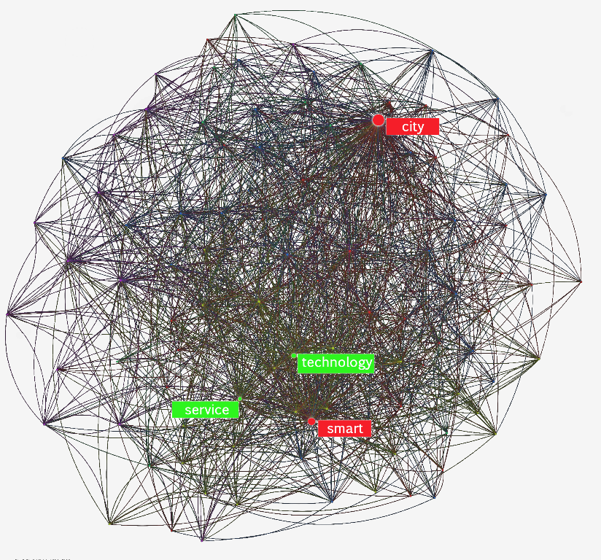

Fig. 2 Graphical representation of the network analysis of the total corpus

2.3 Lexical Correspondence Analysis

The process of analysis begins with the construction of a contingency table (lexical table), which presents terms in rows and in the columns the modes of the variables assigned to the texts, which in our case are the year of publication and the groups of stakeholders (Tab. 1). Plotting the joint frequencies matrix of the variables with specific calculations, we can determine significant associations between groups of words and modes, starting from a probabilistic hypothesis of regular distribution of the forms: when a word is distributed equally in all the sub-texts it is considered trivial; when, instead, it is over-represented in one of the sub-texts it is considered characteristic (Della Ratta, 2007).

|  |  |  |  |
| --- | --- | --- | --- |
| Lemma | Academic | Business | Institution |
| Access | 2 | 7 | 1 |
| Activity | 7 | 2 | 2 |
| Administration | 7 | 6 | 0 |
| Advanced | 5 | 6 | 1 |
| Area | 6 | 10 | 4 |

Tab. 1 Extract from the contingency table of our lexical corpus. At intersections between rows and columns the occurrence of each lemma in all definitions belonging to the corresponding mode (in this case relating to groups of stakeholders).

The software called SPAD was used to analyze these connections, and to break down the lexical table in a series of factors, each of which represents an aspect of the latent type of association present in the data. Based on the results the software plots the two-dimensional dispersion graphics, representing the factorial space on which entries and modes are projected.

The origin of the axes of the graph is the center of gravity of the cloud of points; the more the elements are far from the origin the more their profiles are far from marginal. Examining the entries that are located in periphery, it is therefore possible to attribute to the factorial axes their latent meaning and define the factor space, giving a name to the four quadrants. On the basis of the positioning of the mode in this space so defined, it is possible to describe the unique characteristics that distinguish them (Fig. 3).

To create the vocabulary that has been analyzed the following steps were required:

- Normalization, which consists in the homogenization of the spelling used.

- Lemmatization, which consists in grouping of entries in graphic forms and involves, for example, that the forms of nouns and adjectives are traced to the masculine singular form.

- Selection of the forms on the basis of a minimum threshold frequency, in our case equal to 7.

- Elimination of the so-called empty forms that have only grammatical meaning in relation to other words[2].

The vocabulary thus obtained determines the row entries of the lexical table.

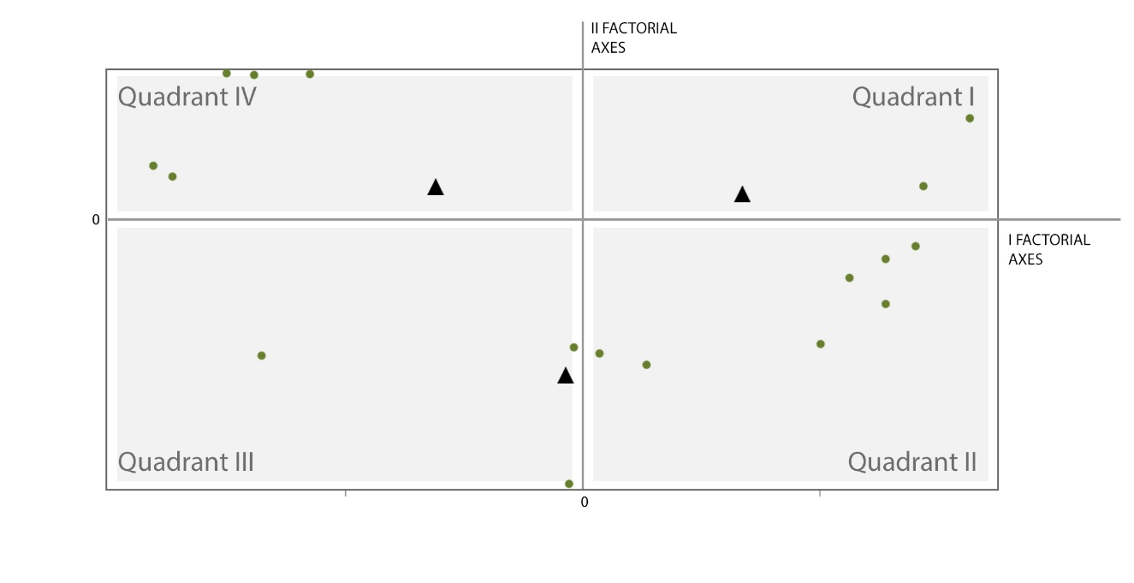

Fig. 3 Scatter chart prepared by Spad software. The two main axes represent the factors and divide the factorial space into four quadrants; black triangles and green circles represent respectively projections of modes and terms on the two factorial axes.

2.4 Method of frequency analysis of lexical units classified in thematic categories

The procedure, before the analysis and interpretation of the individual collected definitions, needs a step to break down the selected corpus in units of analysis, represented, in our case by [**k**] Keywords, and a step of classification of these units into thematic categories.

After the selection of the Keywords the categories were defined ex post[3]. *"What themes are prevalent in the new vision of the city?"*  is the first question that has guided the analysis of the texts and the definition of the following thematic categories[4]: Business, Community, Resource e Network.

The definition of the first three categories derives from the consideration expressed by other authors such as (Papa, 2013), and confirmed by a first investigation of the entire corpus, that the Smart City represents an evolution of what has been defined sustainable city, whose functioning would result from a proper interaction of economy, society and environment.

Compared to the sustainable city, to describe the main topics of Smart City, another category has been inserted that we call Network, linked to the development and use, in recent years, of new information and communication technologies. The themes identified can be defined as follows:

* **[B]** *Business.* includes concepts that refer to a city that interacts with global challenges in terms of economy and investments such as: *economic growth, economic development, start-up, marketing*;
* **[C]** *Community.* Collects all aspects closely related to the organization, the development and the government of the city to provide services in order to achieve a better quality of life. Within this group keyword such as *needs, living, urban planning, security, and lifestyle*;
* **[R]** *Resource.* Considers a series of keywords that refer to a city that interacts with global challenges in environmental terms closely related to resources, natural and otherwise. Some keywords are *climate change, energy, resource, sustainability, resilience*;
* **[N]** *Network.* Collects keyword that relate to the use and implementation of both soft and hard infrastructure, thus promoting mobility, both physical and virtual of people, experience and knowledge; within this group we find keywords such as *infrastructures, ICT, mobility, technology*.

But in the new vision of the city 'What is the role of the town planning? '', and “What role and weight does each stakeholder assign to the specific topics of the discipline of urbanism? “.

To answer these questions, the study focused on the thematic category Community [C], which, in its definition contained elements not related to a specific discipline but generally attributable to collective aspirations; further analysis was carried out, therefore, splitting the category in question into two subcategories, taking as sole criterion the will to distinguish all the keywords related to social aspects, from those related exclusively to urban organization, to its development and its transformation: the first set, called [S] Social Priority, includes keywords such as *quality of life, living and people*, while the second, [U] Urban Planning, includes keywords such as *urban planning* and *urban development*.

To assign keywords to each category [B], [R], [N], [S] and [U] the following classification criteria was used: 1) completeness: no keyword is left out; 2) mutual exclusivity: no keyword is part of more than one category; 3) pairwise comparison: since there is no rule of unique assignment; 4) relevance: the categories identified are considered a priori useful; 5) homogeneity: cases with different characteristics do not fall into the same category.

To ensure the principle of mutual exclusivity we used specifications, in most cases attributable to adjectives, which accompany the coding of keywords and help the correct assignment of each in thematic categories[5].

"Given the role of town planning” by what means is the new city preparing to face the transformation of the territory To answer, all the keywords within the category theme **[U]** Urban Planning were examined, extrapolating the ones most representative both for meaning and for frequency, and analyzing the trend over time and by groups of stakeholders.

The data was summarized in a matrix considering all the variables (Groups of stakeholders: **Ac**ademic, **Ins**titutional and **Bus**iness and years: ≤2010, 2011, 2012, 2013 and 2014) as follows:

|  |  |  |  |  |  |  |  |  |  |  |  |
| --- | --- | --- | --- | --- | --- | --- | --- | --- | --- | --- | --- |
| Definition | Keyword | Specification | U | S | B | N | R | AC | INS | BUS | Year |
| A city where information technology is being incorporated into services that affect urban problems | ICT |  |  |  |  | 1 |  | 1 |  |  | 2013 |
| services |  | 1 |  |  |  |  | 1 |  |  | 2013 |
| problems | Urban | 1 |  |  |  |  | 1 |  |  | 2013 |
| A real smart city develops the city to reach the aim of improving the quality of life. It needs sound and innovative economic development as a means to reach this aim. Uses ICT as a tool with a great potential for ameliorating daily life, public services and the economy. | Quality of life |  |  | 1 |  |  |  |  | 1 |  | ≤2010 |
| development | economic |  |  | 1 |  |  |  | 1 |  | ≤2010 |
| ICT |  |  |  |  | 1 |  |  | 1 |  | ≤2010 |
| services | Public | 1 |  |  |  |  |  | 1 |  | ≤2010 |
| economy |  |  |  | 1 |  |  |  | 1 |  |  |
| Smart cities: Innovative urban developments that leverage ICT for the management of natural energy consumption at the community level and other technologies to balance environmental stewardship with comfortable living. | development | Urban | 1 |  |  |  |  |  |  | 1 | 2014 |
| ICT |  |  |  |  | 1 |  |  |  | 1 | 2014 |
| energy | consumption |  |  |  |  | 1 |  |  | 1 | 2014 |
| technology |  |  |  |  | 1 |  |  |  | 1 | 2014 |
| environment | stewardship |  |  |  |  | 1 |  |  | 1 | 2014 |
| living | comfortable |  | 1 |  |  |  |  |  | 1 | 2014 |

Tab. 2 Excerpt from the table used for the analysis.

Completed the matrix it was possible to proceed with the combination of the variables coded in order to investigate the trends of categories and key concepts.

3 RESULTS

The analysis of the output provided by each of the three methods of lexical analysis described in the previous paragraph has produce several insights. Sifting through the different uses made of the term *smart city* we can, through these instruments, identify whether, and to what extent, the changes advocated in the individual definitions represent an effective response to major modern urban challenges, for example related to the use of land or rationalization of energy resources, or are media instruments in defense of vested interests. Such analysis techniques are, therefore, a useful tool to start a shared analysis of urban transformations necessary for the future of the city, without being blinded by misleading philanthropic claims.

3.1 network text analysis

The main output of this analysis are the *most influential keywords* or node words that are common to the greatest number of contexts (Tab. 3).

|  |  |  |
| --- | --- | --- |
| TOTAL |  | ACCADEMIC |
| Nodes (Words): 100  Edges (Co-Occurrences): 1483 |  | Nodes (Words): 100  Edges (Co-Occurrences): 1250 |
|  |  |  |
| Most influential keywords in this text: |  | Most influential keywords in this text: |
| city smart technology service |  | city smart technology ICT |
|  |  |  |

|  |  |  |
| --- | --- | --- |
| ISTITUTIONAL |  | BUSINESS |
| Nodes (Words): 100,  Edges (Co-Occurrences): 626 |  | Nodes (Words): 100,  Edges (Co-Occurrences): 1207 |
|  |  |  |
| Most influential keywords in this text: |  | Most influential keywords in this text: |
| city smart sustainable management |  | city smart service technology |

Tab. 3 For each corpus the total number of co-occurrences that define the connections, the four node words that connect the stronger contextual themes.

The comparison of the results of the corpus show that, if it is true that among the four most influential keywords you are getting "smart" and "city", the others vary from case to case (Tab. 4).

|  |  |  |  |  |  |
| --- | --- | --- | --- | --- | --- |
| Lemma | Total | Academic | Business | Institutional | Sum |
| City | 1 | 1 | 1 | 1 | 4 |
| Smart | 1 | 1 | 1 | 1 | 4 |
| Technologies | 1 | 1 | 1 |  | 3 |
| Service | 1 |  | 1 |  | 2 |
| ICT |  | 1 |  |  | 1 |
| Sustainable |  |  |  | 1 | 1 |
| Management |  |  |  | 1 | 1 |

Tab. 4 Most influential keywords per sphere of influence

From the table above:

* The word ICT is central only to academia;
* The node word technology is present in the total corpus, business and academia;
* The institutional world uses unique words;
* The node words of all the definitions are the same as the corpus of the business world

These words are not necessarily the most important for the themes found in the text but the ones that strategically link together many of the themes found. We, therefore, propose the following considerations:

* For academics the main interest is the use of new information technologies, which therefore represent the true discriminating character of this urban model.
* Although sharing the interest of technological development with the academic world, the image of the *Smart City* proposed by the business world is centered around the concept of services; for the business world, therefore, a *Smart City* is able to develop and use technology to serve the citizens; since they are manufacturers of devices and sensors we could wonder whether it is not instead a city ​​at the service of technology.
* Institutions have a completely different vision where technology does not seem to play a central role, instead the issues of sustainability and management emerge strongly, in continuity with the previous city models: the smart city is a city that can manage change in a sustainable way. The institutional world seems to not have the need to characterize this new model, but probably uses the brand to perpetuate already initiated policies[6].
* What is most striking is the exact correspondence between node words and totality of definitions and of the business world, demonstrating how companies are driving the debate on the smart city.

3.2 Lexical Correspondence Analysis

The LCA was applied twice on the same textual corpus, using as discriminating modes once the groups of stakeholders and then the year of publication. Following the procedure of analysis described in section 2.3, we proceeded to the interpretation of the scatter charts, with the support of numerical tables, processed by the software together with the graphics, which summarize the coordinates of each lemma for each factor (Tab. 2-3). The results analysis procedure is organized according to the following steps:

- Interpretation of the factorial axes

- Interpretation of the quadrants

- Positioning of the modes (groups of stakeholders, year of publication) within the factorial space

1. LEXICAL CORRESPONDENCE ANALYSIS PER GROUPS OF STAKEHOLDERS

INTERPRETATION OF FACTORIAL AXES

The first step consists in the interpretation of the two factorial axes, which in the specific case represent the 100% of the total variance.

The Ist factorial axis has two opposed groups of words that characterize the two semi axis:

* Positive semi axis: *Vision, Efficiency, Access, Sector, Operation, Solution*.
* Negative semi axis: *Governance, competitiveness, capital, human, policy, modern, transport*.

In the first group words such as *Efficiency, accessibility, solution, vision*, understandable concepts to a wide audience even of non-experts, evoking a fully functional urban dimension. Thus emerges a language, very close to the world of marketing, which focuses on an ideal view of the object (in our case the Smart City) rather than comment on specific processes and tools that describe it. On this basis, this semi axis was named "SUGGESTIONS".

The second group includes words such as *governance, competitiveness,* and *policy* related to a more specialized and less evocative language, that focus on the tools and processes of urban transformation. Words such as *human* and *social capital*, combined with *modern* and *transport* suggest a cross sectorial discussion that involves the field of humanistic and scientific research. This axis was therefore named "tools of transformation."

The IInd factorial axis has two opposed groups of words that characterize the two semi axis:

* Positive semi axis: Policy, capital, human, living, administration, investment, intelligent
* Negative semi axis: Mobility, data, planning, competitiveness, communications, efficiency, reduce

On the positive semi-axis terms that seem to describe a vision of cities attentive to the management (*administration, policy, intelligent*) resources in economic terms (*capital, investment*) and social (*human, living*) emerge; on the negative semi axis instead urban issues are part of a wider path (*mobility*) where the exchange of information and best practices (*data, communications*) become the lifeblood in the resolution of global challenges (*reduce, efficiency, competitiveness*). The two semi axis have therefore been defined respectively "optimization of local resources" and "NETWORKING EXPERIENCES".

INTERPRETATION OF THE QUADRANTS

The interpretation of the axis analyzed earlier, returns a description of the factorial space by assigning a specific meaning to the four quadrants. The first quadrant shows the image of a city in which the use of ICT and the increasing accessibility to these means is the real engine of development of urban areas in terms of management of economic and social resources. The development of new digital technologies takes on, in the second quadrant, a greater interest in relation to the possibility of exchange of experience, know-how, information, best practices between different realities to address common issues and global challenges. Unlike the previous one, the third quadrant, is more focused on the development of tools for urban governance and sharing of experiences becomes a necessary tool to optimize these processes. In the fourth quadrant, the development and implementation of policies and governance tools are more related to the optimization of local resources in economic and social terms.

|  |  |  |
| --- | --- | --- |
| QUADRANT IV: Development of urban governance tools to manage the economic and social resources |  | QUADRANT I: Widespread of ICT to improve the management of local resources |

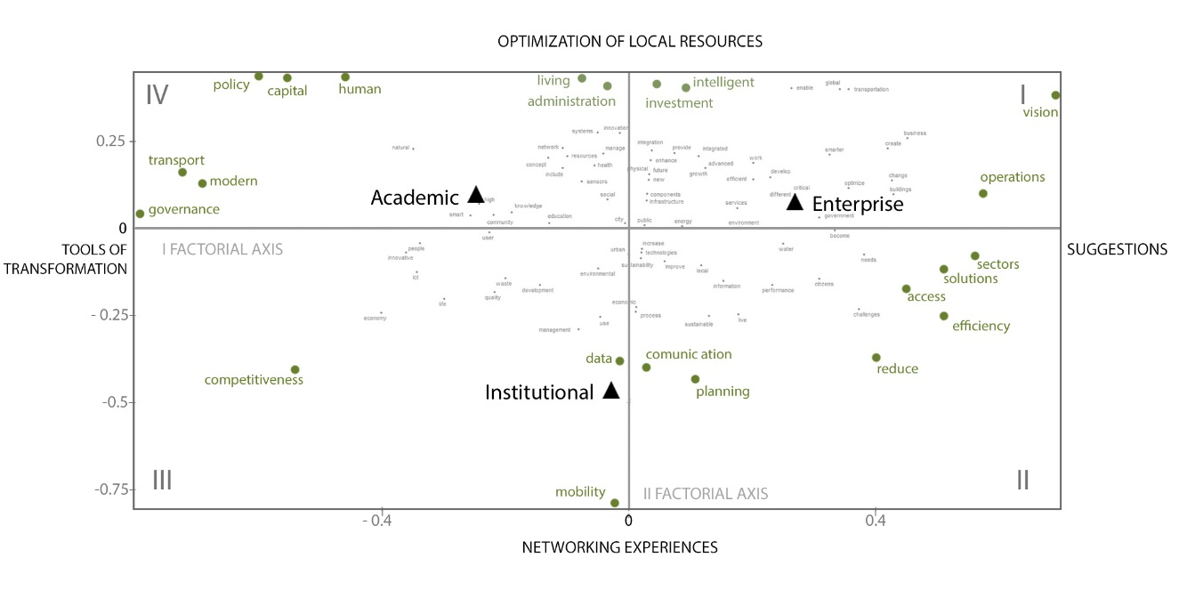

|  |  |  |
| --- | --- | --- |
| QUADRANT III: Development of urban governance tools and disseminations of results |  | QUADRANT II: development of ICT for the know-how exchange |

Fig. 4 Results of the LCA per groups of stakeholders

PLACEMENT OF THE GROUPS OF STAKEHOLDERS IN THE FACTORIAL SPACE

Starting from the considerations made above on the 4 quadrants, it is possible to detect differences in the approach of the three groups of stakeholders under consideration in addressing the issue of the Smart City by analyzing their placement on the factorial plane.

In particular, the opposition is very clear along the horizontal axis of the academic world with that of business, which are located respectively in the I and IV quadrant but is found "lying down" on the first axis. From the description above, it is clear that the development of ICT has led, in the academic world, to pay greater attention to the impact of this revolution in the human and social field and a reflection on the potential of these systems in the management policies of urban organism. On the one hand, therefore, interest of the branch of social sciences emerges, who see in a more or less critical way, the Smart City in the new forms of social interaction, the other the increasing attention from more "technical" disciplines who see this technological revolution, new urban systems optimization tools. On the other side it is obvious that the business world insists more on the attractiveness of new technologies; while sharing with others a series of keywords of the concept of Smart City, it appears more interested in the construction of a language that can reach a wider section of the population, through the use of evocative words.

The institutional world is placed in Quadrant III, and is characterized mainly by the second axis. Its position denotes, therefore, a clear predominance of issues relating to mobility, considered as networking and dissemination of know-how and best practices; This is probably related to the high incidence of the main evaluation factors present in the program guidelines of European calls; they see in multiculturalism and sharing the main requirements for participation, as well as a greater interest in the global challenges in which cities play a decisive role.

1. LEXICAL CORRESPONDENCE ANALYSIS PER YEAR

INTERPRETATION OF FACTORIAL AXIS

In this case the first two factorial axes represent 65% of the total variance.

The Ist factorial axis has two opposed groups of words that characterize the two semi axis:

* Positive semi axis: *critical, administration, operations, physical, activities, sensor, optimize*
* Negative semi axis: *challenge, change, vision, development, policy reduce, energy*

In the first group there are terms related to the production processes (*operations, phisical, activities, sensor, optimize*) that, together with the words *critical* and *administration*, indicate the attention to the development of new technologies and their management. On the opposite axis instead attention is more focused on the socio environmental challenges, terms such *challenge, change,* and *vision* combined with *development policy, reduce,* and *energy* indicate greater interest to the global challenges with particular emphasis on the reduction of energy consumption. The two semi axis have therefore been defined respectively "TECHNOLOGICAL DEVELOPMENT" and "GLOBAL CHALLENGES".

The IInd factorial axis has two opposed groups of words that characterize the two semi axis:

* Positive semi axis*: work, increase, business, public, administration, efficiency, solutions, digital*
* Negative semi axis: *activities, capital, sensors, mobility, smarter, network*

The second axis has on the positive semi axis themes with big media appeal in these tough times, related to employment and management of public money (*work, public, administration*) which are accompanied by the need for economic investments (*solutions, Increase, business*) and related to the production and spread of digital technology (*efficiency, digital*). The negative semi-axis is characterized by terms that conjure the possibility of improving urban performance through the study and analysis of the habits of the inhabitants; the focus is on the potentiality of control (*sensors*) of human activities networks (*activities, mobility, network, capital*) for the creation of smarter cities (*smarter*). The two semi axis have therefore been defined respectively "investment in digital technology" and "BEHAVIOR ANALYSIS".

INTERPRETATION OF THE QUADRANTS

The interpretation of the axis analyzed earlier, returns a description of the factorial space by assigning a specific meaning to the four quadrants. In the first quadrant issues, related to the production, deployment and diffusion of new technologies, especially digital ones, emerge which turn out to be the real engine of economic development of the city.

Instead, in the second quadrant issues related to the development of new technologies for the implementation of the performance in terms of urban development of social networks and infrastructure emerge.

In the third quadrant, development and education of citizens become the real engine of change to address global challenges, a central theme in the fourth quadrant. In this case the challenges, are economic social and environmental: a city is smarter as it is prepared to face the major challenges of the future.

|  |  |  |
| --- | --- | --- |
| QUADRANT IV projections and investments aimed at confronting global challenges |  | QUADRANT I Investments in ICT |

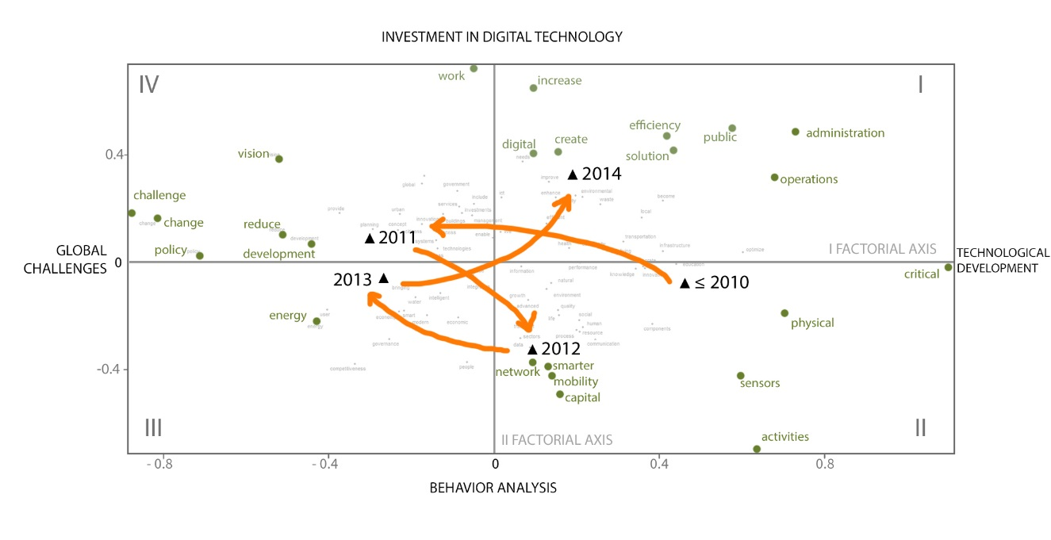

|  |  |  |
| --- | --- | --- |
| QUADRANT III weight of everyday habits in global challenges |  | QUADRANT II development of new technologies for the enhancement of urban performances |

Fig. 5 Results of the LCA per year

PLACEMENT OF THE GROUPS OF STAKEHOLDERS IN THE FACTORIAL SPACE

Starting from the considerations made above on the 4 quadrants and analyzing the positioning of several years on the factorial plane, we can describe the evolutionary trajectory of the themes that have characterized the debate about the Smart City over time.

Based on the description of the interpretation of the factorial space the debate prior to 2010, located in quadrant II seems to be characterized by greater attention to the development of new technologies regardless of the possible fields of application. In 2011, located in the fourth quadrant, switching from a focus on the new tools provided by technology to a greater consideration of the role of cities within the global challenges: control of the new devices has a positive effect on the ability to cope with global challenges starting from city management. To achieve the goals set by the challenges the simple technological development is not enough: in 2012, located in the fourth quadrant, but more "lying" on the second axis than in 2010, the idea that a city to be smart should also implement its networks and social infrastructure seems to prevail. in 2013 the focus moves back to the challenges, but unlike in 2011 with a meaning slightly influenced by social as well as environmental aspects; Finally, in 2014 the development of new technologies is once again at the center of the debate, driven by strong economic interests it becomes the real engine of growth; addressing the major challenges by incorporating into the debate issues of great media impact such as work and the management of public resources. It does not appear coincidental that the strong media character emerges in this last year when, as we shall see in the next section, the main producers of smart devices are more present in the debate on the smart city.

* 1. Method of frequency analysis of lexical units classified in thematic categories

TRENDS OF THE DEFINITIONS

Before proceeding with the application of the analysis, how much the three groups of stakeholders have debated on the issue of Smart City over time was verified. Besides being a useful reference to the study of the results of other analyses, this data has yielded the first important considerations: initially the debate on the smart city is the prerogative of the scientific community, while in 2013 we see a substantial increase in definition by the world of business, represented mainly by manufacturers of electronic devices and software; This probably is due to the spread that the concept of smart city reached just recently becoming a significant element of media appeal; it is no coincidence that in all the web pages of the leading manufacturers of electronic devices (Siemens, IBM, Hitachi etc.) there is a section dedicated to the Smart City. While, on the one side, the academic world seems to abandon the initial enthusiasm for the potential of a Smart City, on the other businesses, use the brand to launch their products in a market mature to accommodate them. How does this difference in approach translates into concrete terms? The frequency analysis of lexical categories has shown the trends of the main themes of a smart city identified by the various groups of stakeholders involved in the debate.

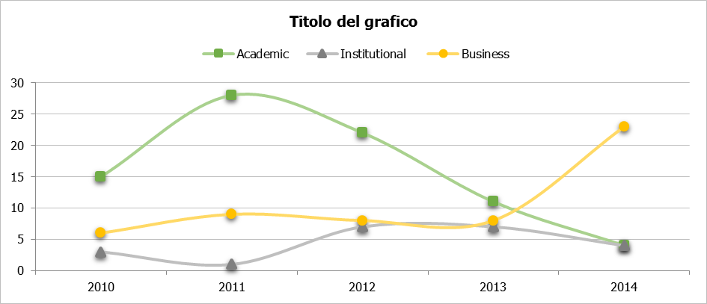

|  |  |  |
| --- | --- | --- |
| BUSINESS | ISTITUTIONAL | ACADEMIC |

|  |  |  |  |  |
| --- | --- | --- | --- | --- |
| ≤ 2010 | 2011 | 2012 | 2013 | 2014 |

Fig. 5 Trends of groups of stakeholders and corresponding weights

From the subdivision of the keywords in thematic categories as described in section 2.4 the following graphics have been developed:

* Trends of the themes for the groups of stakeholders: is the weight that each thematic category plays in the debate within each groups of stakeholders over time;
* Trends of the groups of stakeholders by theme: shows the behavior and the relationship between groups of stakeholders with regard to a specific thematic category over time;
* Trends of the sub-themes [S] Social Priority and [U] Urban Planning: is a focus within the thematic category [C] Community in order to understand the weight of urban transformation in the debate for the three groups of stakeholders in time.
* Trends of the main keywords within the category [U] Urban Planning to understand in which terms the challenges of urban transformation are tackled by the three groups of stakeholders over time.

TRENDS OF THE THEMES FOR THE GROUPS OF STAKEHOLDERS

Fig. 6 Trends of the thematic categories per group of stakeholders

From the analysis of the quadrant I, relating to the 156 definitions, aspects related to global challenges in social and territorial terms and the use of new information and communication technologies are the main themes addressed in the new vision of the city emerge, in spite of a lack of importance given to issues related to economic and environmental aspects, except for a peak of the latter in 2013. The relevance of the topics covered changes within individual groups of stakeholders. The academic world, in the early years, discusses the theme of the Smart City privileging issues related to social and territorial government; by 2012, however, the focus is on the infrastructure system implemented by new technology and its physical and virtual interconnection ability. This change in vision may be due to a greater participation in the debate in the early years, by the branches of social science academics who give way to the scientific and experimental academics, more attracted by the potential of new technologies.

We see this change in the business world (see quadrant IV) albeit with inverse trends; this is probably due to marketing strategies: to a first phase in which the product itself is presented on the market follows a second linked to the need to effectively reach a wider audience, leveraging topics closer to individual aspirations. Institutions instead assign less weight to the technological aspects focusing on the social and giving much more weight than the other groups to environmental issues; This order of priorities is altered from 2013 when it seems to get closer to the positions of businesses.

TRENDS OF THE GROUPS OF STAKEHOLDERS PER THEMATIC CATEGORIES

Fig. 7 The trends of the groups of stakeholders per thematic categories shows the relations amongst the groups.

Looking at the charts shows above we find confirmation to what we have said: in 2013, the curves relating to the business and the institutional world tend to coincide; at a time when the business world enters with more energy in the debate, it seems able to affect institutional priorities, that at the same time move away from the new themes discussed by the scientific community. Another hypothesis, perhaps more likely, is that companies have reformulated the vision of the smart city to tap into funding provided by the EU through programs such as Horizon 2020.

The following table provides a summary of what has been said so far:

|  |  |  |  |  |
| --- | --- | --- | --- | --- |
|  | [B] Business | [C] Community | [N] Network | [R] Resource |
| 1° | **Ist**ituzional | **Ist**ituzional | **Acc**ademic | **B**usiness |
| 2° | **Acc**ademic | **B**usiness | **B**usiness | **Acc**ademic |
| 3° | **B**usiness | **Acc**ademic | **Ist**ituzional | **Ist**ituzional |

Tab. 5 ranking of the groups of stakeholders per thematic category

TRENDS OF THE THEMATIC SUB CATHEGORIES: SOCIAL PRIORITY [S] E URBAN PLANNING [U].

Fig. 8 Trends of [S] Social Priority and [U] Urban Planning

Given that new technologies both hard and soft, and environmental challenges that the economic and social world is facing will determine in fact a monumental change of urban environments, what vision of the city as a community of people who share a physical space arises from the debate on the smart city? To this end, the study focused on the analysis of a single thematic category, Community within which two spheres of influence of the urban / regional system coexist: one linked to the physical transformation of the city associated with the subcategory [U] Urban Planning, and one linked to socio-cultural aspirations of its people, collected in the sub-category [S] Social Priority. Looking at the box I – Total (Fig. 8) all those that place at the center of discussion aspirations and needs of the individual and groups are generally confirmed as central themes; visions and perspectives that imagine a city that invests in human and social capital and its development in terms of well-being, lifestyle and safety. A vision that is shared initially by the academic world but loses force over time, as shown by the descending curve [S] (Fig. 8, Box II). The constant trend of the curve [U] shows that the scientific community, in speaking of the city smart, does not abandon the traditional themes linked to the government of the territory but never assigns it a prominent place. The curve Social Priority [S] is interesting in the IV quadrant where the themes that take shape in the public interest objectives become key topics of discussion for the business world. This confirms what has been said in previous analyzes about the progressive shift of interest towards themes of greater media appeal. Also in this case, the positions of the business world tend to coincide with those of the institutions from 2013.

It is, therefore, evident that the role assumed by planning, understood as government of territorial transformations, is rather marginal in the debate on cities demonstrating little interest in an organic vision of the urban system, probably delegated to a more or less sincere trust in the potentiality of managing the complexity with new technologies.

TRENDS OF THE MAIN KEYWORDS WITHIN THE CATHEGORY URBAN PLANNING

A further study consists in the analysis of the sub-category Urban Planning, in order to understand in what terms, despite it not having a key role, city planning finds its place in the debate on the Smart City. The main keywords (in percentage terms) that emerged from the analysis are: services, which means the fulfillment of essential needs of the community; planning, related to the choices and strategies for transformation and organization of regional planning; governance which seek a governance model characterized by a greater degree of cooperation and interaction between the various actors.

Fig. 9 Trends of Services, Governance, Planning

Meeting the needs of the community by providing services to the citizens is to be, for all three groups of stakeholders, the priority in the new vision of the best way to conceive the urban system. In particular, such an aspiration involves the stakeholders’ part of the business world, most likely because they are interested in reaching a wider audience. The concept of planning, in the traditional sense of the term has maintained a more or less constant trend with low percentages while the issue of governance has gained weight in recent years for all three groups of stakeholders. This is probably due to the fact that as (Rhodes, 1997) states "The concept of governance, now widely used to describe the many types of social and economic coordination, is a change in the meaning of government that refers to a new process and new ways of governing". The governance is, therefore, a new urban development model that takes into account different interests; this model is characterized by a mechanism of incremental growth of the social capital that is based on a greater degree of cooperation and interaction between the stakeholders in the cities.

1. CONCLUSIONS

The results of the analysis conducted, summarized in Tables 6 and 7, show that the different approaches to the issue of the smart city, by the three groups of stakeholders, are clear.

Businesses, represented mainly by manufacturers of electronic devices and software, increasingly involved in the debate on the smart city, see in the spread of this model a significant element of media appeal for the sale of their products; studying the evolution of the concept in the years and the type of language used the marketing strategies employed, emerge: a first phase in which the product itself is presented on the market and a second phase has followed, linked to the need to effectively reach a wider audience, relying on topics closer to individual aspirations and focusing on topics of great media impact such as jobs and management of public resources.

The institutions seem to be more interested in the themes of sustainability and cultural and social mobility, reducing the emphasis on new technologies, which only enhances the ability to circulate know-how; they do not appear to have the need to characterize this new model, but probably use the brand in favor of already initiated policies.

The scientific community has rather more diverse views, originating from the different souls that constitute it, placing the focus of debate on the effects of the development of new information technologies on society; positions coming from the social sciences, that initially prevail, see, in a more or less critical way, the Smart City as new forms of social organization and cultural development, due to an increasing ability to interconnect both physically and virtually; while, at a later time, "technical" disciplines move into the debate, mostly attracted by the potential of new technological systems as a tool for managing the different components of the urban organism in all its forms.

Beyond the differences that characterize the three groups, identified by the study, an alarming fact emerges: the almost complete absence in the debate of the inevitable challenges that cities will face in the near future. Issues such as the limitation of the use of land, the energy efficiency redevelopment of existing buildings, the preservation of the city from the consequences of climate change, etc., and especially the need for an organic vision of the urban system as a whole that addresses all these issues, are only marginally touched by this debate in favor of a, more or less shared, trust in the potentiality of management of complexity through the use of new technologies. In this context it is difficult to set priorities for interventions to be implemented in urban centers channeling investments in a strategic manner.

It is not therefore secondary to figure out who "leads the game" and especially those who "follow": whether to offer solutions for the smart city are businessmen linked to business profits, or institutions crushed by the political election cycles, how can we avoid the risk that everything is conditioned by short term plans?

From the various studies on the temporal evolution of the paradigm we see, in this apparently fragmented and inconsistent field, that the balance of power between the parties involved in the debate is consolidating. From the LCA, which identifies in the investment in the digital technologies the latent underlying significance in the recent debate, and the analysis of the frequency of lexical units, showing a clear convergence in the topics proposed by the business and institutions worlds, it is clear that the debate is increasingly in the hands of businesses, institutions taking a secondary role, while the scientific community tries to carve out their own space with difficulty within the themes promoted by research funding.

The risk of this situation is high, because never as in this historical moment, in which urban centers are growing by leaps and bounds, the short-sighted choices will weigh on the long term, whereas we should carry out a systematic definition of the choices; We may need to start to discuss the issues and problems to be solved, calling them with their names without hiding behind adjectives and brands.

|  |  |  |  |
| --- | --- | --- | --- |
| Stakeholder  Method | Accademic | Istituzional | Business |
| **Network Analysis** | ICT | Sustainable  Management | Services |
| Most influential keywords |
| **LCA** | Transformation tools | Networking Experiences | Suggestions |
| latent meaning |
| **Frequency Analysis** | Network | Community | Community |
| Main thematic category |

Tab. 6 Summary table: diffferent visions of smat city among the stakeholders

|  |  |  |  |  |  |
| --- | --- | --- | --- | --- | --- |
| Year  Method | ≤2010 | 2011 | 2012 | 2013 | 2014 |
| **LCA** | Technological development | Global Challenges | Implementation of technological and social networks | Social Challenges | Investments in digital technologies |
| latent meaning |
| **Frequency Analysis** |  |  |  |  |  |
| accademiic | Community | Community | Community  Network | Network | Network |
| istitutional | Community | - | Community | Community  Network  Resource | Community  Network |
| Business | Network Community | Community | Network Community  Resource | Network  Resource Community | Community |

Tab. 7 Summary table: evolution of the concept of Smart city over the years

Cassa depositi e prestiti. (2013). *Smart City Progetti di sviluppo e strumenti di finanziamento.* Cassa depositi e prestiti S.p.A.

Cavada, M., Hunt, D. V., & Rogers, C. D. (2014). Smart Cities: Contradicting Definitions and Unclear Measures. *World Sustainability Forum 2014.* SciForum, platform for open scholarly exchange and collaboration.

Della Ratta, R. F. (2007). L’analisi testuale computerizzata . In F. L. Cannavo L., *Ricerca sociale, vol. II* (p. 133-152). Roma: Carocci.

European Union (EU) Directorate General for Internal Policies. (2014). *Mapping Smart Cities in the EU.* DIRECTORATE GENERAL FOR INTERNAL POLICIES.

Gargiulo, C., Pinto, V., & Zucaro, F. (2013). EU Smart City Governance. *TeMa Journal of Land use Mobility and Environment*.

Giffinger, R., Fertner, C., Kramar, H., Pichler-Milanovic, N., & Meijers, E. (2007). *Smart cities – Ranking of European medium-sized cities.* Vienna UT: Centre of Regional Science.

Hall, R. E. (2000). The Vision oa A Smart City. *2nd International Life Extension Technology Workshop.* Paris.

ITU-T International Telecomunication Union. (2014). *Smart Sustainable cities: An analysis of definitions.* ITU-T International Telecomunication Union.

Jucevičius, R., Patašienė, I., & Patašius, M. (2014). Digital Dimension of Smart City: Critical Analysis. *Procedia - Social and Behavioral Sciences*.

Lebart, L., & Salem, A. ( 1988). *Analyse statistique des donnèes textuelles.* Parigi: Dunod.

Lombardi, Giordano, S., Farouh, H., & Yousef, W. (2012). Modelling the smart city performance. *Innovation: The European Journal of Social Science Research*.

M.I.T. (2013). *Smart Cities Group*. Tratto da Smart Cities Group: http://smartcities.media.mit.edu/frameset.html

Mosannenzadeh, F., & Vettorato, D. (2014). DEFINING SMART CITY - A CONCEPTUAL FRAMEWORK BASED ON KEYWORD ANALYSIS. *TeMA Journal of Land Use, Mobility and Environment*.

Papa, R. G. (2013). Towards an urban planners’ perspective on Smart City. *Tema. Journal Of Land Use, Mobility And Environment, VI*(1), 5-17.

Paranyushkin, D. (2011). *Identifying the pathways for meaning circulation using text network analysis.* Berlin: Nodus Labs.

Rhodes, W. R. (1997). *Understanding governance. Policy networks, governance, reflexivity and accountability.* Buckingham: Open University Press.

Rios, P. (2012). *Creating the Smart City.* Tratto da archive.udmercy.edu: https://archive.udmercy.edu/handle/10429/393

Santis, R. D., Fasano, A., Mignolli, N., & Villa, A. (2013). *Smart cities: theoretical framework and measurement experiences.* Munich: Munich Personal RePEc Archive.

Schaffers, H., Komninos, N., Pallot, M., Trousse, B., & Nilsson, M. a. (2011). Smart Cities and the Future Internet: Towards Cooperation Frameworks for Open Innovation. *Future Internet Assembly.*

The Climate Group, ARUP, Accenture and The University of Nottingham. (2011). *Information Marketplaces The New Economics of Cities.*

Trobia, A. (2005). *La ricerca sociale quali-quantitativa.* Milano: Franco Angeli.

U.N. Department of Economic and Social Affairs. (2014). *World Urbanization Prospects - The 2014 Revision.* New York.

1. “….Many of these characteristics are given in the three documents analyzed, and from an integrated interpretation the four main actions, listed below, that European cities should undertake in the near future in order to achieve smart, sustainable and inclusive growth: adopt multilevel governance models through the distribution of responsibilities between different government and institutional levels; promote integrated urban policies by adopting a holistic and strategic approach; focus on new information and communication technologies (ICT), in order to provide citizens with new media opportunities and easier access to public and cultural content; ensure sustainable territorial development, based on an efficient use of resource…”

  
2. These are mainly instrumental forms (of, and, that, for, etc.), uninformative and present in all texts. More generically, in each context, all those words that do not report a content relevant for the analysis are defined as empty forms. For this reason, also some adverbs and adjectives that are not considered significant have been eliminated from the vocabulary.
3. The choice of categories can be ex ante or ex post. Ex ante when we have pre-existing categories before the analysis of the corpus, when you want to compare the results with those of other studies, when the theories on a subject are widely established and there is no need to verify them. Ex post that relies on the texts of the corpus to define the concepts useful in describing the investigated phenomenon, when you have a fragmented and unclear vision of the phenomenon, when you want to develop new theories and conceptualizations.
4. Currently in the analysis of content it is possible to identify two types of categories: thematic (the unit of analysis relate to the same subject) and semantics (the unit of analysis have, in the unit of context, the same or similar meaning).
5. Un esempio di questa operazione è riscontrabile nella codifica del termine ‘Development’ che ha rivelato, durante la lettura dei testi, diverse accezioni, ciascuna delle quali ha determinato l'assegnazione della stessa keyword in categorie differenti: cultural development [C]; economic development [B]; technological development [N]; sustainable development [R].
6. It’s important to point out that most of the definitions collected from the institutional world, and included in this category, belong to documents of the European community; for many of them environmental issues, particularly those related to resource management, whether energy or economy, are central.